Barret’s Chapel School
Middle School (6th, 7th, & 8th)
T-shirt Order Form

Shirt Details:  - Shirt color: Kelly Green  - Writing: Navy Blue  - Background: White | 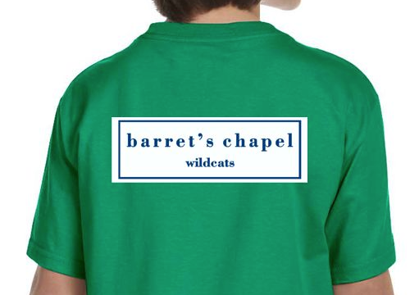

Barret’s Chapel Middle School shirts are now on sale.
Show your class spirit and order one today!
Please return order forms with payment by Tuesday, September 8
Cash: Exact change only..
Checks: Payable to Barret’s Chapel School.

All shirts are $8.50 each.
Size | Quantity | Total Price
Adult
X-Small
Adult
Small
Adult
Medium
Adult
Large
Adult
X-Large
Adult
2X-Large

Student: ___________________Grade: ____Homeroom:__________

