You’re invited
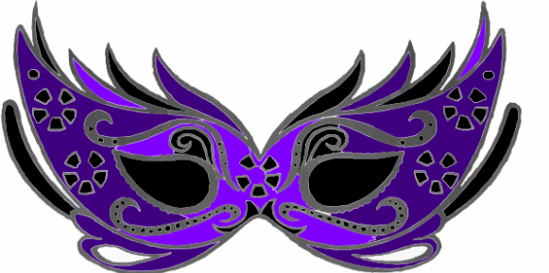
To a
Masquerade Ball

Sponsored by:
Barret’s Chapel Middle School Student Council
When: Friday, November 13, 2015
Time: 3:30-5 pm
Where: Barret’s Chapel Gym
Price: $6 (*** refreshments and snacks will be sold at the dance for an additional fee)
*** This event is open only to 6-8 grade Barret’s Chapel students.

Student: ____________________________________
Grade: _______
Homeroom : ____________________
***** I give my child permission to attend the Masquerade Ball at Barret’s Chapel from 3:30-5 on Friday, November 13.

Parent/Guardian Signature & contact information: ___________________________________________________________________________________________
If needed: my child has permission to ride home with ________________________________

***Exact Change Only or checks made to Barret’s Chapel (BCS)

