Rachel Stafford
8th U.S. History
Lesson Plans
Week of: January 23-27, 2017

Monday, January 23, 2017
TN Core Standard(s)  TEACH 1: Objective Driven Lesson (Engage students in objective-driven lessons based on content standards) | Growth and Expansion  (Chapter 11)  1790-1840  8.20 Explain the impact of individuals who created interest in the land west of the Appalachian Mountains, including: (C, G, H, TN)  • _long hunters  • _Wilderness Road  • _Daniel Boone  • _William Bean  • _Thomas Sharpe Spencer  • _Dr. Thomas Walker  8.39 Identify the leaders and events and analyze the impact of western expansion to the development of Tennessee statehood, including: (G, H, P, TN)  • _William Blount  • _John Sevier  • _Rocky Mount  • _Treaty of Holston  • _Cumberland Gap  • _River systems  • _Natchez Trace  • _Jackson Purchase  8.45 Analyze the relationship the United States had with Europe, including the influence of the Monroe Doctrine (E, G, P)  8.47 Explain the causes and effects of the wave of immigration from Northern Europe to the United States, and describe the growth in the number, size, and special arrangements of cities as a result of such events as the Great Potato Famine. (C, E, G, P)  8.50 Identify common themes in American art and literature, including transcendentalism and individualism by analyzing essays and stories by American writers. (C)  8.51 Trace the development of the agrarian economy in the South, the locations of the cotton-producing states, and the significance of cotton, the cotton gin and the role of Memphis as the Cotton Capital of the South. (C, E, G, P, TN)  8.72 Identify on a map the boundaries constitution the North and the South and delineate and evaluate the geographical differences between the two regions, including the differences between agrarians and industrialists. (E, G, P)  8. 73 Describe the influence of industrialization and technological developments of the regions, including human modification of the landscape and how physical geography shaped human actions-growth of cities, deforestation, farming and mineral extraction (E, G, H, P)
Guiding Question(s)  TEACH 1: Objective Driven Lesson (Engage students in objective-driven lessons based on content standards) | - How does geography influence the way people live?  - Why does Conflict Develop?
Objective(s)  TEACH 1: Objective Driven Lesson (Engage students in objective-driven lessons based on content standards) | I can analyze the aspirations and ideals of the people of the new nation.  I cans analyze the paths of the American people in the three regions of the United States from 1800 to the mid-1800s and the challenges they faced as they became increasingly sectionalized.
Agenda  TEACH 7: Instructional Time (Maximize Instructional Time) | - Collect Chapter 10 Writing  - Review main points of chapter 10  - Introduce chapter 11  - Annotations and text dependent questions for Westward (1190L)  - Writing Activity
Bell Work (connect to prior knowledge) | - Turn in chapter 10 writing (if needed)  - Review main ideas of chapter 10
Instructional Strategies (I do)  TEACH 2: Explain Content (Explain content clearly and accurately) | Introduce chapter 11  - Objectives  - Guiding Questions  - TN Core Standards  - Pre-Test  - Projected Dates
Differentiated Tasks  (We do)  TEACH 3: Appropriately Challenging Work (Engage students at all learning levels in appropriately challenging work)  TEACH 4: Content Engagement (provide students with multiple ways to engage with content) | Close Read with annotations Westward (1190L)
Assessments  (They do)  TEACH 3: Appropriately Challenging Work (Engage students at all learning levels in appropriately challenging work)  TEACH 4: Content Engagement (provide students with multiple ways to engage with content) | Close Read with annotations Westward (1190L)
Closure | Imagine that you are a Native American forced to relocate west of the Mississippi Rive Along the Trail of Tears. Would you find your relocation to be fair, legal or justified? Explain and justify your reasoning in a 6-8 sentence paragraph with 1-2 pieces of textual evidence (provided from the passage).
Homework | Chapter 11- Homework Questions  - 11-1: Wednesday, January 25  - 11-2: January 26  - 11-3: February 11  - Cumulative HW Turn In: Thursday, February 2  Chapter 11  - Mid-chapter Quiz: Thursday, January 26  - Vocabulary Quiz: Wednesday, February 1  - Journal Check: Rubrics issued Tuesday, January 31- All Journals must be checked by Friday, February 3  - Chapter Test: Thursday, February 2  - In Class Writing: There will be no formal writing for this chapter
Looking Ahead  If students finish ahead of time. | 11-1 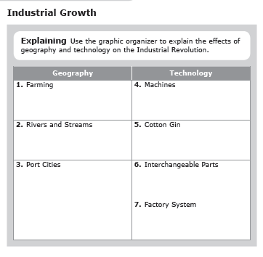

Tuesday, January 24, 2017

TN Core Standard(s)  TEACH 1: Objective Driven Lesson (Engage students in objective-driven lessons based on content standards) | Growth and Expansion  (Chapter 11)  1790-1840  8.51 Trace the development of the agrarian economy in the South, the locations of the cotton-producing states, and the significance of cotton, the cotton gin and the role of Memphis as the Cotton Capital of the South. (C, E, G, P, TN)  8.72 Identify on a map the boundaries constitution the North and the South and delineate and evaluate the geographical differences between the two regions, including the differences between agrarians and industrialists. (E, G, P)  8. 73 Describe the influence of industrialization and technological developments of the regions, including human modification of the landscape and how physical geography shaped human actions-growth of cities, deforestation, farming and mineral extraction (E, G, H, P)
Guiding Question(s)  TEACH 1: Objective Driven Lesson (Engage students in objective-driven lessons based on content standards) | How does geography influence the way people live?
Objective(s)  TEACH 1: Objective Driven Lesson (Engage students in objective-driven lessons based on content standards) | I can analyze the aspirations and ideals of the people of the new nation.  I cans analyze the paths of the American people in the three regions of the United States from 1800 to the mid-1800s and the challenges they faced as they became increasingly sectionalized.
Agenda  TEACH 7: Instructional Time (Maximize Instructional Time) | - Return Chapter 10 Test and issue Reinforcement Activity.  - Analyze Chapter 11, Lesson 1  - Reflection; Writing  - Exit Ticket
Bell Work (connect to prior knowledge) | How do you think the innovations of the 1700s affected people? Do you think they affect people more or less than todays changes? (Pair/Share)
Instructional Strategies (I do)  TEACH 2: Explain Content (Explain content clearly and accurately) | 11-1: A Growing Economy  pages 296-301  Industrial Growth (p. 296-298)  - Industrial Revolution  - How did new technologies change the way people worked?  - Why did industries flourish in New England?  - What was a cotton gin?  - What were interchangeable parts?  - Protecting Inventions  - How did countries try to protect the rights of inventors?  - Why do you think it was important to protect these rights?  - Explain how the textile industry grew in the United States.  - Free Enterprise  - What is capitalism?  - 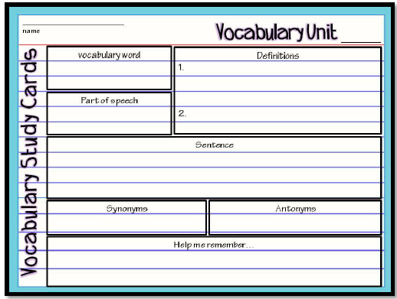  - What is free enterprise?
Differentiated Tasks  (We do)  TEACH 3: Appropriately Challenging Work (Engage students at all learning levels in appropriately challenging work)  TEACH 4: Content Engagement (provide students with multiple ways to engage with content) | Agriculture Grows p. 299  - Summarize  - Northeast  - The West  - The South  Economic Independence p. 300-301  - Why do people invest money?  - What is a corporation?  - How did trade cause the growth of cities?
Assessments  (They do)  TEACH 3: Appropriately Challenging Work (Engage students at all learning levels in appropriately challenging work)  TEACH 4: Content Engagement (provide students with multiple ways to engage with content) | Reflection with justification through textual evidence:  - How do patents support free enterprise?  - How did improvements in transportation affect trade and travel?
Closure | 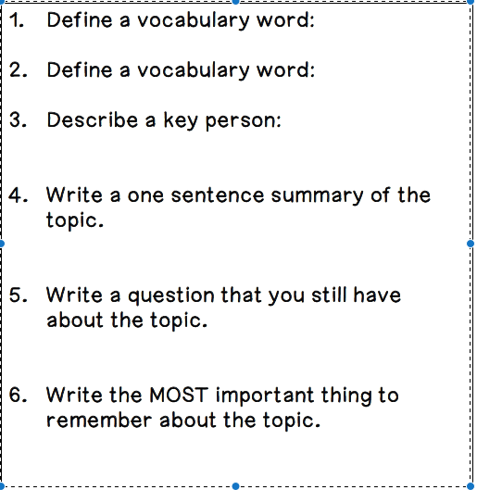
Homework | Chapter 11- Homework Questions  - 11-1: Wednesday, January 25  - 11-2: January 26  - 11-3: February 11  - Cumulative HW Turn In: Thursday, February 2  Chapter 11  - Mid-chapter Quiz: Thursday, January 26  - Vocabulary Quiz: Wednesday, February 1  - Journal Check: Rubrics issued Tuesday, January 31- All Journals must be checked by Friday, February 3  - Chapter Test: Thursday, February 2  - In Class Writing: There will be no formal writing for this chapter
Looking Ahead  If students finish ahead of time. | 11-2  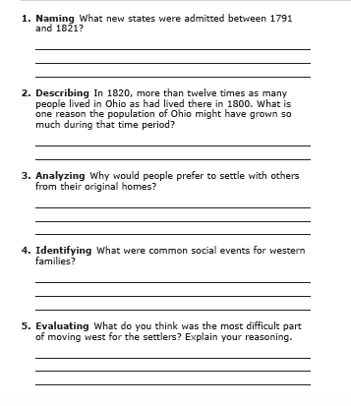

Wednesday, January 25, 2017

TN Core Standard(s)  TEACH 1: Objective Driven Lesson (Engage students in objective-driven lessons based on content standards) | Growth and Expansion  (Chapter 11)  1790-1840  8.20 Explain the impact of individuals who created interest in the land west of the Appalachian Mountains, including: (C, G, H, TN)  • _long hunters  • _Wilderness Road  • _Daniel Boone  • _William Bean  • _Thomas Sharpe Spencer  • _Dr. Thomas Walker  8.39 Identify the leaders and events and analyze the impact of western expansion to the development of Tennessee statehood, including: (G, H, P, TN)  • _William Blount  • _John Sevier  • _Rocky Mount  • _Treaty of Holston  • _Cumberland Gap  • _River systems  • _Natchez Trace  • _Jackson Purchase  8.47 Explain the causes and effects of the wave of immigration from Northern Europe to the United States, and describe the growth in the number, size, and special arrangements of cities as a result of such events as the Great Potato Famine. (C, E, G, P)
Guiding Question(s)  TEACH 1: Objective Driven Lesson (Engage students in objective-driven lessons based on content standards) | How does geography influence the way people live?
Objective(s)  TEACH 1: Objective Driven Lesson (Engage students in objective-driven lessons based on content standards) | I can analyze the aspirations and ideals of the people of the new nation.  I cans analyze the paths of the American people in the three regions of the United States from 1800 to the mid-1800s and the challenges they faced as they became increasingly sectionalized.
Agenda  TEACH 7: Instructional Time (Maximize Instructional Time) | - Review 11-1  - Analyze Chapter 11, Lesson 2  - Reflection; Writing  - Map Activity  - Exit Ticket
Bell Work (connect to prior knowledge) | 11-1 homework questions  Vocabulary Box: Industrial Revolution  How did the Industrial Revolution affect the way people lived in the United States?
Instructional Strategies (I do)  TEACH 2: Explain Content (Explain content clearly and accurately) | 11-2: Moving West pages 302-307  Headed West, p. 302-306  - Daniel Boone  - Who was Daniel Boone?  - What was the Cumberland Gap?  - How did the Wilderness Road increase westward migration?
Differentiated Tasks  (We do)  TEACH 3: Appropriately Challenging Work (Engage students at all learning levels in appropriately challenging work)  TEACH 4: Content Engagement (provide students with multiple ways to engage with content) | Improving Transportation  (Summarize)  - Roadways  - Steamboats  - Erie Canal  The Move West Continues p. 306-307  -Map Activity The Move West 1790-1821
Assessments  (They do)  TEACH 3: Appropriately Challenging Work (Engage students at all learning levels in appropriately challenging work)  TEACH 4: Content Engagement (provide students with multiple ways to engage with content) | *Reflection with Justification Through Textual Evidence.  - How did the population West of the Appalachian Mountains change from 1800-1820?  - Where did pioneer families tend to settle? Why?
Closure | 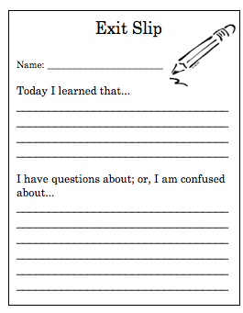
Homework | Chapter 11- Homework Questions  - 11-1: Wednesday, January 25  - 11-2: January 26  - 11-3: February 11  - Cumulative HW Turn In: Thursday, February 2  Chapter 11  - Mid-chapter Quiz: Thursday, January 26  - Vocabulary Quiz: Wednesday, February 1  - Journal Check: Rubrics issued Tuesday, January 31- All Journals must be checked by Friday, February 3  - Chapter Test: Thursday, February 2  - In Class Writing: There will be no formal writing for this chapter
Looking Ahead  If students finish ahead of time. | 11-3  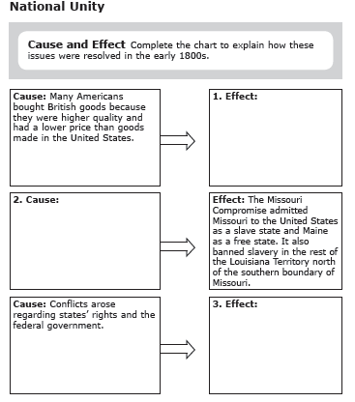

Thursday,

TN Core Standard(s)  TEACH 1: Objective Driven Lesson (Engage students in objective-driven lessons based on content standards) | Growth and Expansion  (Chapter 11)  1790-1840  8.20 Explain the impact of individuals who created interest in the land west of the Appalachian Mountains, including: (C, G, H, TN)  • _long hunters  • _Wilderness Road  • _Daniel Boone  • _William Bean  • _Thomas Sharpe Spencer  • _Dr. Thomas Walker  8.39 Identify the leaders and events and analyze the impact of western expansion to the development of Tennessee statehood, including: (G, H, P, TN)  • _William Blount  • _John Sevier  • _Rocky Mount  • _Treaty of Holston  • _Cumberland Gap  • _River systems  • _Natchez Trace  • _Jackson Purchase  8.47 Explain the causes and effects of the wave of immigration from Northern Europe to the United States, and describe the growth in the number, size, and special arrangements of cities as a result of such events as the Great Potato Famine. (C, E, G, P)
Guiding Question(s)  TEACH 1: Objective Driven Lesson (Engage students in objective-driven lessons based on content standards) | How does geography influence the way people live?
Objective(s)  TEACH 1: Objective Driven Lesson (Engage students in objective-driven lessons based on content standards) | I can analyze the aspirations and ideals of the people of the new nation.  I cans analyze the paths of the American people in the three regions of the United States from 1800 to the mid-1800s and the challenges they faced as they became increasingly sectionalized.
Agenda  TEACH 7: Instructional Time (Maximize Instructional Time) | - 11-2 HW Questions  - Whole class review of 11-1 & 11-2  - Summarizing Activity (Pair/Share)  - Describing Reflection (pair/share)  - Mid-Chapter Quiz  - Writing Activity
Bell Work (connect to prior knowledge) | 11-2 HW  Review main ideas of chapter 11, lesson 1 & 2
Instructional Strategies (I do)  TEACH 2: Explain Content (Explain content clearly and accurately) | Summarizing (pair/share)  - What did Americans do in the late 1700s and early 1800s to improve the movement of people and goods?  Describing (pair/share)  - How did Rivers play a role in the settlement of the west?
Differentiated Tasks  (We do)  TEACH 3: Appropriately Challenging Work (Engage students at all learning levels in appropriately challenging work)  TEACH 4: Content Engagement (provide students with multiple ways to engage with content) | Mid-chapter Quiz covering lesson 1 & 2 (independent assessment, no outside resources)
Assessments  (They do)  TEACH 3: Appropriately Challenging Work (Engage students at all learning levels in appropriately challenging work)  TEACH 4: Content Engagement (provide students with multiple ways to engage with content) | Mid-chapter Quiz covering lesson 1 & 2 (independent assessment, no outside resources)
Closure | Write a paragraph explaining how life in the west was different from life in the east.  - 8-10 sentences  - topic and conclusion  - 2 pieces of textual evidence (cited As seen on page __)
Homework | Chapter 11- Homework Questions  - 11-1: Wednesday, January 25  - 11-2: January 26  - 11-3: February 11  - Cumulative HW Turn In: Thursday, February 2  Chapter 11  - Mid-chapter Quiz: Thursday, January 26  - Vocabulary Quiz: Wednesday, February 1  - Journal Check: Rubrics issued Tuesday, January 31- All Journals must be checked by Friday, February 3  - Chapter Test: Thursday, February 2  - In Class Writing: There will be no formal writing for this chapter
Looking Ahead  If students finish ahead of time. | 11-3  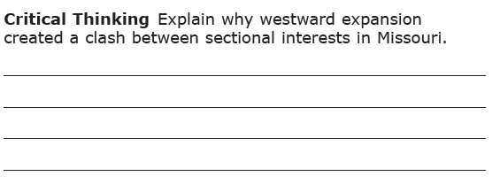

Friday, January 27, 2017

TN Core Standard(s)  TEACH 1: Objective Driven Lesson (Engage students in objective-driven lessons based on content standards) | Growth and Expansion  (Chapter 11)  1790-1840  8.50 Identify common themes in American art and literature, including transcendentalism and individualism by analyzing essays and stories by American writers. (C)
Guiding Question(s)  TEACH 1: Objective Driven Lesson (Engage students in objective-driven lessons based on content standards) | How does geography influence the way people live?
Objective(s)  TEACH 1: Objective Driven Lesson (Engage students in objective-driven lessons based on content standards) | I can analyze the aspirations and ideals of the people of the new nation.  I cans analyze the paths of the American people in the three regions of the United States from 1800 to the mid-1800s and the challenges they faced as they became increasingly sectionalized.
Agenda  TEACH 7: Instructional Time (Maximize Instructional Time) | ***Middle School Awards Programs will take place from 8:45 am till around 9:45 am. This will cause a disruption the regular schedule and cause 1st and second period to be very short or completely cut  - Review Activity  - Literature Connection- Mark Twain  - Writing Reflection with Justification
Bell Work (connect to prior knowledge) | How did the Industrial Revolution affect the population of farms and cities?
Instructional Strategies (I do)  TEACH 2: Explain Content (Explain content clearly and accurately) | Pair/Share & Class discussion  - How did the increase for cotton change the population of the South?  - What factors contributed to the westward expansion in the early 1800s?
Differentiated Tasks  (We do)  TEACH 3: Appropriately Challenging Work (Engage students at all learning levels in appropriately challenging work)  TEACH 4: Content Engagement (provide students with multiple ways to engage with content) | Life on the Mississippi River, p. 316-317 (Literature Connection)  - From the description of the story, do you think everything in it will be strictly factual? Why or why not?  - How did the life of the steamboat workers change with the increase in steamboats?  - Reflection Questions, p. 317 (1-3)
Assessments  (They do)  TEACH 3: Appropriately Challenging Work (Engage students at all learning levels in appropriately challenging work)  TEACH 4: Content Engagement (provide students with multiple ways to engage with content) | Reflection with Justification  - What can you infer about Mark Twains life through this passage?  - What did you learn about Mark Twain’s attitude toward the MS River and the characters who traveled it?
Closure | 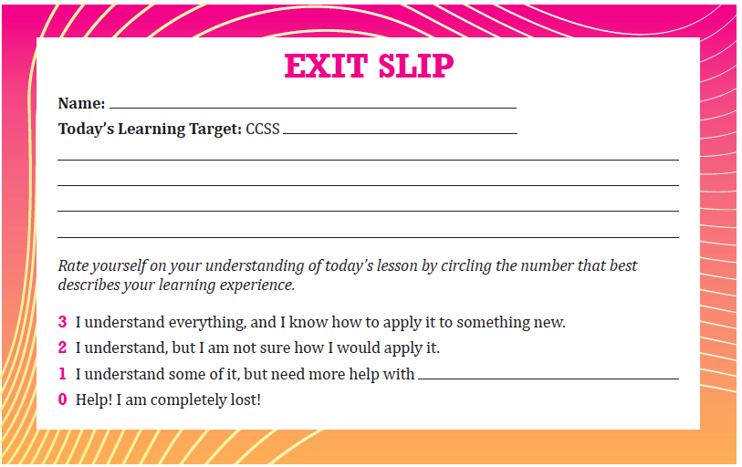
Homework | Chapter 11- Homework Questions  - 11-1: Wednesday, January 25  - 11-2: January 26  - 11-3: February 11  - Cumulative HW Turn In: Thursday, February 2  Chapter 11  - Mid-chapter Quiz: Thursday, January 26  - Vocabulary Quiz: Wednesday, February 1  - Journal Check: Rubrics issued Tuesday, January 31- All Journals must be checked by Friday, February 3  - Chapter Test: Thursday, February 2  In Class Writing: There will be no formal writing for this chapter
Looking Ahead  If students finish ahead of time. | 11-3  