Rachel Stafford
8th U.S. History
Lesson Plans
Week of: January 30-February 3, 2017

Monday, January 30, 2017

TN Core Standard(s)  TEACH 1: Objective Driven Lesson (Engage students in objective-driven lessons based on content standards) | Growth and Expansion  (Chapter 11)  1790-1840  - 8.38 Describe daily life — including traditions in art, music, and literature — of early national America by examining excerpts from the stories of Washington Irving and James Fenimore Cooper. (C, H, P)  - 8.44 Identify on a map the changing boundaries of the United States, including the Convention of 1818 and Adams-Onis Treaty. (G, P)  - 8.45 Analyze the relationship the United States had with Europe, including the influence of the Monroe Doctrine (E, G, P)  - 8.63 Trace the major figures and events in the discovery of gold in California and its impact on the economy of the United States, including John Sutter, and 49’ers. (C, E, G, H)  - 8.65 Describe the reasons for and the impact of the Missouri Compromise of 1820. (G, H, P)
Guiding Question(s)  TEACH 1: Objective Driven Lesson (Engage students in objective-driven lessons based on content standards) | - Why does Conflict Develop?
Objective(s)  TEACH 1: Objective Driven Lesson (Engage students in objective-driven lessons based on content standards) | I can analyze the aspirations and ideals of the people of the new nation.  I cans analyze the paths of the American people in the three regions of the United States from 1800 to the mid-1800s and the challenges they faced as they became increasingly sectionalized.
Agenda  TEACH 7: Instructional Time (Maximize Instructional Time) | - Collect Chapter 10 writing  - Collect chapter 10 reinforcement activity  - Independent analysis of 11-3
Bell Work (connect to prior knowledge) | Write a paragraph explaining how the War of 1812 changed the way people felt about the role of the central government.
Instructional Strategies (I do)  TEACH 2: Explain Content (Explain content clearly and accurately) | National Unity  Cause and Effect graphic organizer  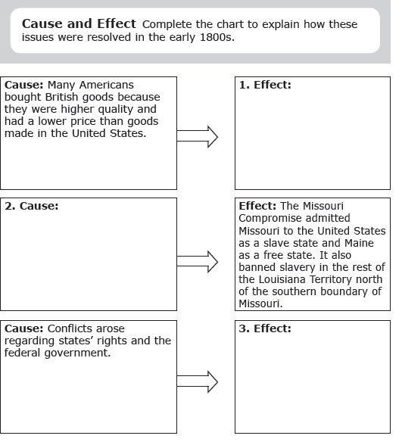  Critical Thinking: Explain why westward expansion created a clash between sectional interests in MO.
Differentiated Tasks  (We do)  TEACH 3: Appropriately Challenging Work (Engage students at all learning levels in appropriately challenging work)  TEACH 4: Content Engagement (provide students with multiple ways to engage with content) | Answering Text Dependent Questions  - Summarizing: What were the results of the Convention of 1818?  - Explaining: Why was there a dispute over control of West FL between Spain and the United States?  - Explaining: Why was General Andrew Jackson ordered to enter Spanish FL?  - Describing: Hos did General Andrew Jackson’s actions contribute to the United States gaining control over FL?  - Identifying: Under what treaty did Spain finally give up FL to the US?  - Describing: How did Spain lose power to its empire in the Americas?  - Analyzing: What was the Monroe Doctrine and why was it important?  - Explaining: What event led President Monroe to issue his warning statement?
Assessments  (They do)  TEACH 3: Appropriately Challenging Work (Engage students at all learning levels in appropriately challenging work)  TEACH 4: Content Engagement (provide students with multiple ways to engage with content) | Primary Source Analysis: Why We Need a Protective Tariff  Analyzing Primary Sources  - Identifying: In what ways does the author show how a protective tariff will benefit people of his town?  - Expressing: How does the author illustrate that the town would be negatively affected if the factory was to close?  - Describing: According to the editorial, what is the proper method for setting questions of economic and national policy?  - Making Connections: Why might a modern artworker employed by an American manufacturer favor a protective tariff today? Why might American consumers oppose such a tariff?  - Making Inference: What is the purpose of the author’s opening paragraph?
Closure | Sectionalism  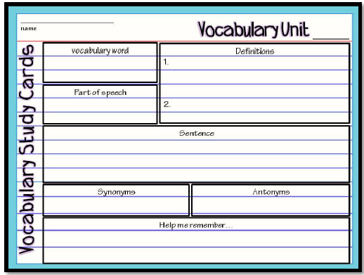
Homework | Chapter 11- Homework Questions  - 11-1: Wednesday, January 25  - 11-2: January 26  - 11-3: February 11  - Cumulative HW Turn In: Thursday, February 2  Chapter 11  - Mid-chapter Quiz: Thursday, January 26  - Vocabulary Quiz: Wednesday, February 1  - Journal Check: Rubrics issued Tuesday, January 31- All Journals must be checked by Friday, February 3  - Chapter Test: Thursday, February 2  - In Class Writing: There will be no formal writing for this chapter
Looking Ahead  If students finish ahead of time. | 11-3: What was the purpose of Henry Clay’s American System?

Tuesday, January 31

TN Core Standard(s)  TEACH 1: Objective Driven Lesson (Engage students in objective-driven lessons based on content standards) | Growth and Expansion  (Chapter 11)  1790-1840  - 8.38 Describe daily life — including traditions in art, music, and literature — of early national America by examining excerpts from the stories of Washington Irving and James Fenimore Cooper. (C, H, P)  - 8.44 Identify on a map the changing boundaries of the United States, including the Convention of 1818 and Adams-Onis Treaty. (G, P)  - 8.45 Analyze the relationship the United States had with Europe, including the influence of the Monroe Doctrine (E, G, P)  - 8.63 Trace the major figures and events in the discovery of gold in California and its impact on the economy of the United States, including John Sutter, and 49’ers. (C, E, G, H)  8.65 Describe the reasons for and the impact of the Missouri Compromise of 1820. (G, H, P)
Guiding Question(s)  TEACH 1: Objective Driven Lesson (Engage students in objective-driven lessons based on content standards) | Why does Conflict Develop?
Objective(s)  TEACH 1: Objective Driven Lesson (Engage students in objective-driven lessons based on content standards) | I can analyze the aspirations and ideals of the people of the new nation.  I cans analyze the paths of the American people in the three regions of the United States from 1800 to the mid-1800s and the challenges they faced as they became increasingly sectionalized.
Agenda  TEACH 7: Instructional Time (Maximize Instructional Time) | - Return Chapter 11 mid-chapter Quiz  - Issue Journal Check Rubrics  - Analyze 11-3
Bell Work (connect to prior knowledge) | What factors probably made life in the West difficult? How did rivers play a role in the settlement of the West?
Instructional Strategies (I do)  TEACH 2: Explain Content (Explain content clearly and accurately) | 11-3: Unity & Sectionalism  National Unity p. 308-312  Era of Good Feelings  - Who won the election of 1816?  - Who was Henry Clay? What did he propose?  How did the 2nd Bank of the United States help the economy?  Competition From Britain  - Why did people prefer British goods?  - How did the Tariff of 1816 protect American manufacturing?  - Why did the Tariff in 1818 and 1824 anger some Americans?
Differentiated Tasks  (We do)  TEACH 3: Appropriately Challenging Work (Engage students at all learning levels in appropriately challenging work)  TEACH 4: Content Engagement (provide students with multiple ways to engage with content) | Sectionalism Who? Where?  North  South  West  Nationalism & the Supreme Court  Summarize  - Fletcher v. Peck  - McCullough v. MD  - Gibbons v. Ogden  MO Compromise  - Why did the Senate block the MO Territory’s statehood?  - What was the MO Compromise?
Assessments  (They do)  TEACH 3: Appropriately Challenging Work (Engage students at all learning levels in appropriately challenging work)  TEACH 4: Content Engagement (provide students with multiple ways to engage with content) | Reflection with Justification through textual evidence:  How well did the MO Compromise solve the sectional conflict? Explain and justify your reasoning.
Closure | 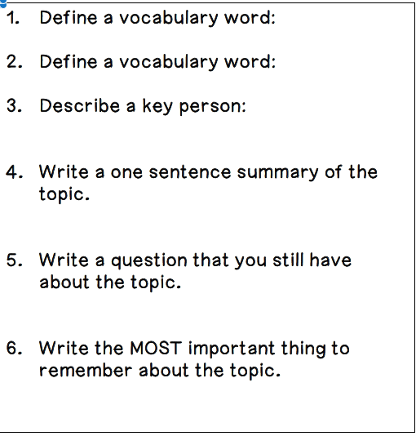
Homework | Chapter 11- Homework Questions  - 11-1: Wednesday, January 25  - 11-2: January 26  - 11-3: February 11  - Cumulative HW Turn In: Thursday, February 2  Chapter 11  - Mid-chapter Quiz: Thursday, January 26  - Vocabulary Quiz: Wednesday, February 1  - Journal Check: Rubrics issued Tuesday, January 31- All Journals must be checked by Friday, February 3  - Chapter Test: Thursday, February 2  - In Class Writing: There will be no formal writing for this chapter
Looking Ahead  If students finish ahead of time. | How did the spread of the population in the United States over a wider area create challenges and tensions? Write a three paragraph essay with three pieces of textual evidence that answers this questions.

Wednesday, February 1

TN Core Standard(s)  TEACH 1: Objective Driven Lesson (Engage students in objective-driven lessons based on content standards) | Growth and Expansion  (Chapter 11)  1790-1840  - 8.38 Describe daily life — including traditions in art, music, and literature — of early national America by examining excerpts from the stories of Washington Irving and James Fenimore Cooper. (C, H, P)  - 8.44 Identify on a map the changing boundaries of the United States, including the Convention of 1818 and Adams-Onis Treaty. (G, P)  - 8.45 Analyze the relationship the United States had with Europe, including the influence of the Monroe Doctrine (E, G, P)  - 8.63 Trace the major figures and events in the discovery of gold in California and its impact on the economy of the United States, including John Sutter, and 49’ers. (C, E, G, H)  8.65 Describe the reasons for and the impact of the Missouri Compromise of 1820. (G, H, P)
Guiding Question(s)  TEACH 1: Objective Driven Lesson (Engage students in objective-driven lessons based on content standards) | Why does Conflict Develop?
Objective(s)  TEACH 1: Objective Driven Lesson (Engage students in objective-driven lessons based on content standards) | I can analyze the aspirations and ideals of the people of the new nation.  I cans analyze the paths of the American people in the three regions of the United States from 1800 to the mid-1800s and the challenges they faced as they became increasingly sectionalized.
Agenda  TEACH 7: Instructional Time (Maximize Instructional Time) | - BW  - Finish 11-3  - 11-3 HW Questions  - Chapter 11 Vocabulary Quiz
Bell Work (connect to prior knowledge) | Why was the MO Compromise a temporary solution?
Instructional Strategies (I do)  TEACH 2: Explain Content (Explain content clearly and accurately) | Foreign Affairs p. 313-315  - What happened in 1810?  - Describe  - Rush-Bagot Agreement 1817  - Convention of 1818  - What were the terms of the Adams-Onis Treaty of 1819?  - Why did some southerners want FL to be controlled by the US?  - Why did Andrew Jackson take US troops into FL?
Differentiated Tasks  (We do)  TEACH 3: Appropriately Challenging Work (Engage students at all learning levels in appropriately challenging work)  TEACH 4: Content Engagement (provide students with multiple ways to engage with content) | Monroe Doctrine  - Why was Spain losing power in the Americas?  - Why was President Monroe concerned about the European Powers?  - What was the Monroe Doctrine?
Assessments  (They do)  TEACH 3: Appropriately Challenging Work (Engage students at all learning levels in appropriately challenging work)  TEACH 4: Content Engagement (provide students with multiple ways to engage with content) | - Discuss 11-3 HW  - Chapter 11 Vocabulary Quiz
Closure
Homework | Chapter 11- Homework Questions  - 11-1: Wednesday, January 25  - 11-2: January 26  - 11-3: February 11  - Cumulative HW Turn In: Thursday, February 2  Chapter 11  - Mid-chapter Quiz: Thursday, January 26  - Vocabulary Quiz: Wednesday, February 1  - Journal Check: Rubrics issued Tuesday, January 31- All Journals must be checked by Friday, February 3  - Chapter Test: Thursday, February 2  In Class Writing: There will be no formal writing for this chapter
Looking Ahead  If students finish ahead of time. | How did the spread of the population in the United States over a wider area create challenges and tensions? Write a three paragraph essay with three pieces of textual evidence that answers this questions.

Thursday, February 2

TN Core Standard(s)  TEACH 1: Objective Driven Lesson (Engage students in objective-driven lessons based on content standards) | Growth and Expansion  (Chapter 11)  1790-1840  8.20 Explain the impact of individuals who created interest in the land west of the Appalachian Mountains, including: (C, G, H, TN)  • _long hunters  • _Wilderness Road  • _Daniel Boone  • _William Bean  • _Thomas Sharpe Spencer  • _Dr. Thomas Walker  8.39 Identify the leaders and events and analyze the impact of western expansion to the development of Tennessee statehood, including: (G, H, P, TN)  • _William Blount  • _John Sevier  • _Rocky Mount  • _Treaty of Holston  • _Cumberland Gap  • _River systems  • _Natchez Trace  • _Jackson Purchase  8.45 Analyze the relationship the United States had with Europe, including the influence of the Monroe Doctrine (E, G, P)  8.47 Explain the causes and effects of the wave of immigration from Northern Europe to the United States, and describe the growth in the number, size, and special arrangements of cities as a result of such events as the Great Potato Famine. (C, E, G, P)  8.50 Identify common themes in American art and literature, including transcendentalism and individualism by analyzing essays and stories by American writers. (C)  8.51 Trace the development of the agrarian economy in the South, the locations of the cotton-producing states, and the significance of cotton, the cotton gin and the role of Memphis as the Cotton Capital of the South. (C, E, G, P, TN)  8.72 Identify on a map the boundaries constitution the North and the South and delineate and evaluate the geographical differences between the two regions, including the differences between agrarians and industrialists. (E, G, P)  8. 73 Describe the influence of industrialization and technological developments of the regions, including human modification of the landscape and how physical geography shaped human actions-growth of cities, deforestation, farming and mineral extraction (E, G, H, P)
Guiding Question(s)  TEACH 1: Objective Driven Lesson (Engage students in objective-driven lessons based on content standards) | - How does geography influence the way people live?  - Why does Conflict Develop?
Objective(s)  TEACH 1: Objective Driven Lesson (Engage students in objective-driven lessons based on content standards) | I can analyze the aspirations and ideals of the people of the new nation.  I cans analyze the paths of the American people in the three regions of the United States from 1800 to the mid-1800s and the challenges they faced as they became increasingly sectionalized.
Agenda  TEACH 7: Instructional Time (Maximize Instructional Time) | - Submit Chapter 11 Homework  - Chapter 11 Test  - Slavery and Sectionalism passage  - Writing Activity
Bell Work (connect to prior knowledge) | Oral Review of Chapter 11 (whole class)
Instructional Strategies (I do)  TEACH 2: Explain Content (Explain content clearly and accurately) | - Chapter 11 Test  - Close read with annotations and text dependent questions Sectionalism and Slavery (1190L)  - Introduce Chapter 12  - Pre-Test  - TN Core Standards  - Dates
Differentiated Tasks  (We do)  TEACH 3: Appropriately Challenging Work (Engage students at all learning levels in appropriately challenging work)  TEACH 4: Content Engagement (provide students with multiple ways to engage with content) | - Chapter 11 Test  - Close read with annotations and text dependent questions Sectionalism and Slavery (1190L)  - Introduce Chapter 12  - Pre-Test  - TN Core Standards  - Dates
Assessments  (They do)  TEACH 3: Appropriately Challenging Work (Engage students at all learning levels in appropriately challenging work)  TEACH 4: Content Engagement (provide students with multiple ways to engage with content) | - Chapter 11 Test  - Close read with annotations and text dependent questions Sectionalism and Slavery (1190L)  - Introduce Chapter 12  - Pre-Test  - TN Core Standards  - Dates
Closure
Homework | Chapter 11- Homework Questions  - 11-1: Wednesday, January 25  - 11-2: January 26  - 11-3: February 11  - Cumulative HW Turn In: Thursday, February 2  Chapter 11  - Mid-chapter Quiz: Thursday, January 26  - Vocabulary Quiz: Wednesday, February 1  - Journal Check: Rubrics issued Tuesday, January 31- All Journals must be checked by Friday, February 3  - Chapter Test: Thursday, February 2  In Class Writing: There will be no formal writing for this chapter
Looking Ahead  If students finish ahead of time. | How did the spread of the population in the United States over a wider area create challenges and tensions? Write a three paragraph essay with three pieces of textual evidence that answers this questions.

Friday, February 3
**Today is an 8th grade field trip to Rock the Presidents. We will not meet with all classes.

TN Core Standard(s)  TEACH 1: Objective Driven Lesson (Engage students in objective-driven lessons based on content standards) | The Jackson Era  (Chapter 12)  1824-1845  - Identify the constitutional issues posed by the doctrine of nullification and secession and analyze the earliest origins of that doctrine. (C, P)  - Explain the events and impact of the presidency of Andrew Jackson, including the “corrupt bargain,” the advent of Jacksonian Democracy, his use of the spoils system and the veto, his battle with the Bank of the United States, the Nullification Crisis and the Indian removal. (C, E, G, H, P, TN)  - Analyze the contributions of Sequoyah to the Cherokee. (C, TN)  - Write a narrative piece that describes the impact of the Indian Removal Act of 1830 and the struggle between the Cherokee Nation and the United States government and cites evidence from primary source accounts of the Trail of Tears. (C, G, H, TN)
Guiding Question(s)  TEACH 1: Objective Driven Lesson (Engage students in objective-driven lessons based on content standards) | - What are the characteristics of a leader?  - What are the consequences when cultures interact?  - How do governments change?
Objective(s)  TEACH 1: Objective Driven Lesson (Engage students in objective-driven lessons based on content standards) | I can analyze the paths of the American people in the three regions of the United States from 1800 to the mid-1800s and the challenges they faced as they became increasingly sectionalized.
Agenda  TEACH 7: Instructional Time (Maximize Instructional Time) | Writing Assignment  Members of Congress agreed to the MO Compromise in an attempt to prevent serious conflict. Write a letter to a member of Congress (historically accurate) for or against this compromise. Justify your opinion through textual evidence.
Bell Work (connect to prior knowledge) | Writing Assignment  Members of Congress agreed to the MO Compromise in an attempt to prevent serious conflict. Write a letter to a member of Congress (historically accurate) for or against this compromise. Justify your opinion through textual evidence.
Instructional Strategies (I do)  TEACH 2: Explain Content (Explain content clearly and accurately) | Writing Assignment  Members of Congress agreed to the MO Compromise in an attempt to prevent serious conflict. Write a letter to a member of Congress (historically accurate) for or against this compromise. Justify your opinion through textual evidence.
Differentiated Tasks  (We do)  TEACH 3: Appropriately Challenging Work (Engage students at all learning levels in appropriately challenging work)  TEACH 4: Content Engagement (provide students with multiple ways to engage with content) | Writing Assignment  Members of Congress agreed to the MO Compromise in an attempt to prevent serious conflict. Write a letter to a member of Congress (historically accurate) for or against this compromise. Justify your opinion through textual evidence.
Assessments  (They do)  TEACH 3: Appropriately Challenging Work (Engage students at all learning levels in appropriately challenging work)  TEACH 4: Content Engagement (provide students with multiple ways to engage with content) | Writing Assignment  Members of Congress agreed to the MO Compromise in an attempt to prevent serious conflict. Write a letter to a member of Congress (historically accurate) for or against this compromise. Justify your opinion through textual evidence.
Closure | 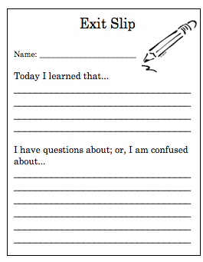
Homework | Chapter 12- Homework Questions  - 12-1: Tuesday, February 7  - 12-2: Thursday, February 9  - 12-3: Wednesday, February 15  - Cumulative HW Turn In: Friday, February 17  Chapter 12  - Mid-chapter Quiz: Thursday, February 9  - Vocabulary Quiz: Thursday, February 16  - Journal Check: Friday, February 17  - Chapter Test: Friday, February 17  In Class Writing: There will be no formal writing for this chapter
Looking Ahead  If students finish ahead of time. | Chapter 12: Enrichment  Why do you think Andrew Jackson was so popular in the 1820s & 1830s? Do you think he would be as popular a leader today? Research and examine information on President Jackson, President Trump, President Obama and President George W. Bush. Then write an essay that examines Jackson popularity with the popularity of our mist current presidents.

