Shelby County Schools Weekly Lesson Analysis/Planning Document
Social Studies Grades K-12

Teacher’s Name: Rachel Stafford Grade Level / Module: 8th U.S. History
Week of Aug. 21-25 | Monday | Tuesday | Wednesday | Thursday | Friday
SS TN Standard(s): | - Eclipse Day | - 8.10 | - 8.2 | - 8.8, 8.12, 8.14 | - 8.12, 8.13, 8.15, 8.16, 8.28
Student Outcomes:  What will students know and be able to do as a result of this lesson? | - Eclipse Day | - Student can compare and contrast the features of the early colonies and identify the key figures in each.  - Student can tell you why settlers came from England. | Student can tell you  - About interactions between Native Americans & colonists.  - How life was difficult for different kinds of people in colonial society.  - How and why chattel slavery came to the colonies. | Student can tell you  - About interactions between Native Americans & colonists.  - How life was difficult for different kinds of people in colonial society.  - How and why chattel slavery came to the colonies. | Student can tell you  - About interactions between Native Americans & colonists.  - How life was difficult for different kinds of people in colonial society.  - How and why chattel slavery came to the colonies.
Key Academic Vocabulary: | Eclipse Day |  |  | Subsistence Farming  Cash Crop  Diversity  Triangular Trade  Slave Code | Representative Government  Mercantilism  Export  import
Resources / Materials: | - Eclipse Day | Chapter 3 Writing Assignment | - Chapter 4 Student Information  - Chapter 4 Pre-Test  - Powhatan Exchanges Views with Captain John Smith  - Colonial America Dependent on the Enslavement of Indigious People | - Chapter 4  - Lesson 1: Colonial Economy  - When Humans Became Inhumane | - Chapter 4  - Lesson 2: Colonial Government
Warm-Up / Bell Ringer:  Examples: Identifications, Vocabulary, Map Skills  (Suggest no more than 5 minutes.) | Eclipse Day | Open notebook Map Quiz_ The English Colonies | Chapter 4 Pre-Test | Annotation: Emergence of Colonial Government | - If the population in the neighborhoods around the school grew dramatically, what changes might take place in your neighborhood and classroom?  - What are some reasons that people might immigrate to the colonies in large numbers?  - How could an outbreak of smallpox affect the population?
Essential Question / Relevance: Develop student interest and connect learning to  daily standards. | Eclipse Day | How did geography, religion, and government affect how people in the English colonies lived? | - How did freedom from oppression and greed coexist in the colonies?  - How did wealth influence quality of life?  - How does ownership of human beings damage society? | - How did freedom from oppression and greed coexist in the colonies?  - How did wealth influence quality of life?  - How does ownership of human beings damage society? | - How did freedom from oppression and greed coexist in the colonies?  - How did wealth influence quality of life?  - How does ownership of human beings damage society?
High-Quality Text(s): | - Eclipse Day |  | - Powhatan Exchanges Views with Captain John Smith  - Colonial America Dependent on the Enslavement of Indigious People | - When Humans Became Inhumane  - Chapter 4, Lesson 1  - Narrative of O. Equiano (p. 90-91) | - Chapter 4, Lesson 2
Text-Specific Inquiry:  Teacher guided inquiry into content-rich texts,  images or other content. | - Eclipse Day | Directions: Respond to the following question. Your answer must be 3 paragraphs (opening/thesis, Body/supporting details- with 3 pieces of textual evidence, and conclusion). This assignment must be written in blue or black ink or typed. | - Powhatan Exchanges Views with Captain John Smith  - What evidence does the account give that Powhatan is suspicious of the motives of the colonists?  - What part of Powhatan’s statements suggest that both Natives and Colonists benefit from peace?  - Based on the evidence in this article, what can you infer about the power of Powhatan’s tribe compared to that of the colonists?  - What evidence suggests that the colonists feel that they may be outgrowing their relationship with the Native Americans?  - How do both Powhatan and Smith use veiled threats to emphasize their position?  - How does this exchange typify the relationship between colonists and native people in the early days of settlement?  - Based on what you know of John Smith from reading The Starving Times, do you believe that his response to Powhatan was honest?  - How would the attitudes about Natives expressed here by John Smith contribute to their subjugation to colonial slavery?  - Does the fact that the Native American tribes have existed for centuries before the arrival of the colonist seem to matter to John Smith? How do you know? Why do you think this is true or not? | Natural Resources Jobs & Industry  New  England  Middle  Southern  Growth of Slavery p. 87-89  The Middle Passage  - What was it?  - Describe how it affected enslaved Africans?  Slave Codes  - What was the purpose?  - How did they affect enslaved Africans? | English Principles of Government (p. 92-94)  Explain:  - Magna Carta  - Representative Government  - English Bill of Rights  Types of Colonial Government (Explain)  - Charter  - Colony  - Proprietary Colony  - Royal Colony
Text-Specific Application:  Teacher facilitated small group or partner  strategies to deepen student understanding and  foster robust, collaborative discussion. | - Eclipse Day |  | Colonial America Dependent on the Enslavement of Indigious People  - Summarize the three main ideas of this passage | MAP Activity: Triangular Trade  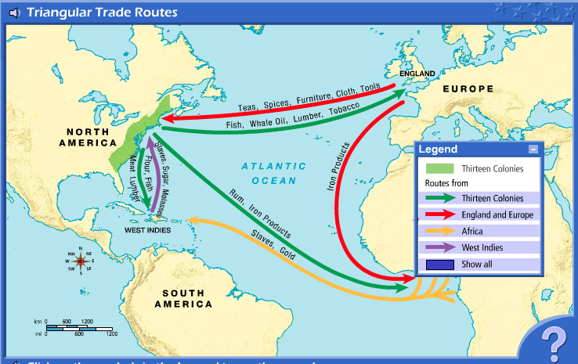  Why did slavery grow faster in the southern colonies than in other colonies? | English Economic Policies (p. 94-95)  - Mercantilism  - What is it?  - How did England benefit from mercantilism?  - How did the colonies benefit from mercantilism?  - Navigation Acts  - What were they?  - Why did the colonists expect the acts in the beginning?  - Why did the colonists later resent the Acts?
Closure:  Individual students synthesize and/or summarize  learning for the day. | Eclipse Day |  | Story Matters p. 81  Places & Time p. 82-83  Questions 1-3 | - When Humans Became Inhumane  - Narrative of O. Equiano (p. 90-91) | Reflection  (Justification with textual evidence)  - Where did the colonists get their ideas about government?  - How did the colonists react to Britain’s economic policies?
Weekly Assessment:  Guidance is provided weekly in the map to  support robust student writing every week that is strongly aligned to Social Studies content  standards. | Eclipse Day |  | Chapter 4  - Mid Chapter Quiz: August 28  - Vocabulary Quiz: August 31  - Journal Check: September 1  - Test: September 1 | Chapter 4  - Mid Chapter Quiz: August 28  - Vocabulary Quiz: August 31  - Journal Check: September 1  - Test: September 1 | Chapter 4  - Mid Chapter Quiz: August 28  - Vocabulary Quiz: August 31  - Journal Check: September 1  - Test: September 1
Homework: | Eclipse Day |  | Homework Chapter 4  - 4-1: August 25  - 4-2: August 28  - 4-3: August 30  - 4-4: August 31  - Final HW Turn in: September 1 | Homework Chapter 4  - 4-1: August 25  - 4-2: August 28  - 4-3: August 30  - 4-4: August 31  - Final HW Turn in: September 1 | Homework Chapter 4  - 4-1: August 25  - 4-2: August 28  - 4-3: August 30  - 4-4: August 31  - Final HW Turn in: September 1

