Teacher | Rachel Stafford
Class | 8th United States History

 | Date:  Mon., Aug. 15 | Date:  Tues., Aug. 16 | Date:  Wed. Aug. 17 | Date:  Thurs, Aug. 18 | Date:  Fri., Aug. 19
Standard | **** No standards are being covered at this time, we are reviewing 7th grade material. | **** No standards are being covered at this time, we are reviewing 7th grade material. | **** No standards are being covered at this time, we are reviewing 7th grade material. | **** No standards are being covered at this time, we are reviewing 7th grade material. | **** No standards are being covered at this time, we are reviewing 7th grade material.
Objective  I can…..  (Chapter information & I can statement) | Chapter 1, Lesson 3  North American Peoples  I can analyze and explain how early Native Americans adapted to their environment. | Chapter 2, Lesson 1  A Changing World  I can:  - Identify and describe geographical places and regions such as north and central Africa or SW North America  - Explain events of the Age of Exploration both graphically and orally. | Chapter 2, Lesson 2  Early Exploration  I can:  - Compare and contrast information about European Explorers and exploration.  - Identify and describe geographical places and regions such as north and central Africa or SW North America.  - Explain events of the Age of Exploration both graphically and orally. | Chapter 2, Lesson 3  Spain in America  I can:  - Compare and contrast information about European Explorers and exploration.  - Analyze relationships between explorers and Native Americans.  - Understand the impact and importance of events, such as the defeat of the Aztecs or the establishment of Spanish missions. | Chapter 2, Lesson 4  Competing for Colonies  I can:  - Identify and describe geographical places and regions such as north and central Africa or SW North America.  - Explain events of the Age of Exploration both graphically and orally.
Connections to Prior Knowledge | Bell Work:  - States’ Abbreviation Practice  - Parts of a Map Foldable  - Aztec/Incas Analysis | Bell Work:  - Crusades  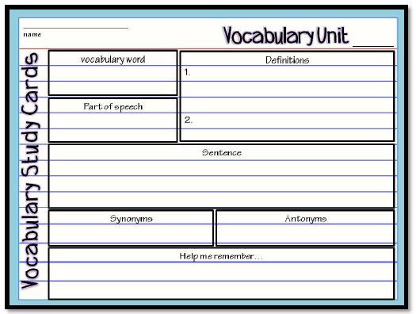 | Bell Work:  - Activity: Columbian Exchange  - Close-Read: Columbus As a Young Boy | Bell Work:  Conquistador  Plantation | Bell Work:  Review States Abbreviation  *** Abbreviation Final Assessment
Guiding Questions | How do civilizations rise and fall? | How do new ideas change the way people live? | Why do people trade? | What are the consequences when cultures interact? | What are the consequences when cultures interact?

Instructional Strategies  I do… | Teacher Notes  Graphic Orga nizer | Notes:  Renaissance | Foldable: Columbus  - What did he believe?  - Why did Queen Isabella support him?  - What did Columbus find? | Graphic Organizer  Explorer- Region Explored  - Cortez  - Pizarro  - Leon  - De Soto | Activity- The Reformation  How did religion affect Europe?
Differentiated Tasks  We do … | Map Activity | Vocabulary Foldable: Improvements in Technology | Explorer/Vocab.  Journal entry  - Vespucci  - Balboa  - Magellan | Analyze: The Effects of Native Americans | Activity:  NW Passage  French Settlement
Assessment  They do …. | Which Native American group stands out the most and why? | Tri-Fold:  Ghana, Mali & Songhai | Why did Europeans what to explore?  Explain how new technologies allowed Europeans to explore more of the world than they had prior to Columbus? (must cite textual evidence) | Why did Spain Encourage the conquistadors?  *** State Abbreviation Practice Test | Vocabulary Boxes:  Reformation  Protestantism  NW Passage
Homework | Homework  Study for State Abbreviation Test (Friday) | Homework  Study for State Abbreviation Test (Friday) | Homework  Study for State Abbreviation Test (Friday) | Homework  Study for State Abbreviation Test (Friday) | Homework  Study for State Abbreviation Test (Friday)
Closure | Exit Slip  3: List 3 things you learned today  2: Explain 2 ways you contributed to class today  1: identify at least one question you still have. | Exit Slip  3: List 3 things you learned today  2: Explain 2 ways you contributed to class today  1: identify at least one question you still have. | Exit Slip  3: List 3 things you learned today  2: Explain 2 ways you contributed to class today  1: identify at least one question you still have. | Exit Slip  3: List 3 things you learned today  2: Explain 2 ways you contributed to class today  1: identify at least one question you still have. | Exit Slip  3: List 3 things you learned today  2: Explain 2 ways you contributed to class today  1: identify at least one question you still have.
Resources/Materials | Computer  Projector  Student text books  Interactive journals  Colored pencils  Tape/glue  TE-online book | Computer  Projector  Student text books  Interactive journals  Colored pencils  Tape/glue  TE-online book | Exit Slip  3: List 3 things you learned today  2: Explain 2 ways you contributed to class today  1: identify at least one question you still have. | Computer  Projector  Student text books  Interactive journals  Colored pencils  Tape/glue  TE-online book | Computer  Projector  Student text books  Interactive journals  Colored pencils  Tape/glue  TE-online book
Projected Assessments
Additional notes/ Upcoming Events | Please make sure you are reviewing your notes from your interactive notebook each night. | Please make sure you are reviewing your notes from your interactive notebook each night. | Please make sure you are reviewing your notes from your interactive notebook each night. | Please make sure you are reviewing your notes from your interactive notebook each night. | Please make sure you are reviewing your notes from your interactive notebook each night.

