Teacher | Rachel Stafford
Class | 8th United States History

 | Date:  Mon., Sept. 7 | Date:  Tues., Sept. 8 | Date:  Wed. Sept. 9 | Date:  Thurs., Sept. 10 | Date:  Fri., Sept. 11
Standard | No School  Labor Day | 8.12 Compare and contrast the day to day colonial life for men, women and children in different regions and of different ethnicities, including the systems of indentured servitude, as well as their connection to the land.  8.13 Analyze the ideas that significantly impacted the development of colonial self government by citing textual evidence and examining multiple perspectives. | 8.12 Compare and contrast the day to day colonial life for men, women and children in different regions and of different ethnicities, including the systems of indentured servitude, as well as their connection to the land.  8.13 Analyze the ideas that significantly impacted the development of colonial self government by citing textual evidence and examining multiple perspectives. | 8.12 Compare and contrast the day to day colonial life for men, women and children in different regions and of different ethnicities, including the systems of indentured servitude, as well as their connection to the land.  8.13 Analyze the ideas that significantly impacted the development of colonial self government by citing textual evidence and examining multiple perspectives. | 8.10 Locate and identify the first 13 colonies describing how their location and geographic features influenced their development.  8.12 Compare and contrast the day to day colonial life for men, women and children in different regions and of different ethnicities, including the systems of indentured servitude, as well as their connection to the land.  8.13 Analyze the ideas that significantly impacted the development of colonial self government by citing textual evidence and examining multiple perspectives.  8.14 Identify the origins and development of slavery in the colonies, overt and passive resistance to enslavement and the Middle Passage
Objective  I can….. | No School  Labor Day | I can  understand the social, political and economic reasons for the movement of people from Europe to the Americas, and they will describe the impact of colonization by Europeans on American Indians and on the development of the land that eventually became the United States of America. | I can  understand the social, political and economic reasons for the movement of people from Europe to the Americas, and they will describe the impact of colonization by Europeans on American Indians and on the development of the land that eventually became the United States of America. | I can  understand the social, political and economic reasons for the movement of people from Europe to the Americas, and they will describe the impact of colonization by Europeans on American Indians and on the development of the land that eventually became the United States of America. | I can  understand the social, political and economic reasons for the movement of people from Europe to the Americas, and they will describe the impact of colonization by Europeans on American Indians and on the development of the land that eventually became the United States of America.
Connections to Prior Knowledge | No School  Labor Day | Pair/Share: Middle Passage Review: The Interesting Narrative of the Life of Olaudah Equiano  Analyzing Literature p. 91 (1-3: complete sentences)  Bell work:  If the population of a school grew dramatically, what changes might take place in your neighborhood or classroom? | Pair/Share then whole group of students response: (previous lesson)  Do you think a person can be of good character and not contribute much to society? DO you think a person can have bad character and still make some contribution to society? | Whole Group:  Discuss the French and British influence in America.  - Consider current places in the U.S. that reflect French and British influences and explain why you think that is so. | Bell work  Write your answer as a complete statement, restating the question in your answer.  Why is the label the French and Indian war as it is a misleading documentation?
Guiding Questions | No School  Labor Day | How do new ideas change the way people live? | How do new ideas change the way people live? | How did competition for land in North America lead to the French and Indian War? | Why does conflict develop?

Instructional Strategies  I do… | No School  Labor Day | - Introduce Focus Questions  - Vocabulary/Key Terms  - Power point with notes  - (Pair/Share) Text Dependent Questions (Focus Questions) | Review Previous lesson. Break into groups for Literary Analysis activity.  - The Great Awakening  - The Enlightenment | - Introduce Focus Questions  - Vocabulary/Key Terms  - Power point with notes  - (Pair/Share) Text Dependent Questions (Focus Questions) | Whole class discussion  What did each of these groups want or need during the colonial period in America?  English government, colonists, French settlers, native Americans, African Americans
Differentiated Tasks  We do … | No School  Labor Day | - (Pair/Share) Text Dependent Questions (Focus Questions)  - Individual Work  - Vocabulary Boxes for  - Civic Virtue  - The Great Awakening  - Enlightenment  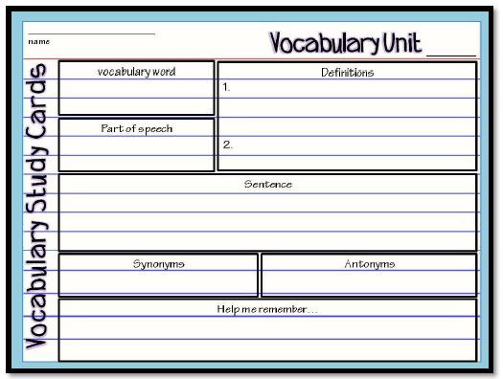 | Literary Analysis Activity  - Religious Movements in Early America  - The Great Awakening  - Enlightenment & John Locke | - (Pair/Share) Text Dependent Questions (Focus Questions)  - Individual Work  Analysis: Thinking Like a Historian p. 103  - What do the letters represent? How do you know this?  - How does the phrase “Unite or Die” relate to the segmented snake?  - Summarize your interpretation of this political cartoon explain how your knowledge of the 13 colonies helped guide you to this conclusion. | - (Pair/Share) create and organize the whole class discussion (as a chart/diagram in your interactive notebook.  What did each of these groups want or need during the colonial period in America?  English government, colonists, French settlers, native Americans, African Americans  Individual Assessment: Vocabulary QUiz
Assessment  They do …. | No School  Labor Day | Examine your notes on Enlightenment that we discussed today and answer the questions in a 5-8 sentence paragraph.  Do you think a person can be of good character and not contribute much to society? DO you think a person can have bad character and still make some contribution to society? | Examine your notes on Enlightenment that we discussed today and answer the questions in a 5-8 sentence paragraph.  How did the Great Awakening affect the role of churches in the colonies |  | Examine your notes on Enlightenment that we discussed today and answer the questions in a 5-8 sentence paragraph.  How did the lives of the colonists change as events of the seventeenth and eighteenth centuries unfolded?
Closure | No School  Labor Day | 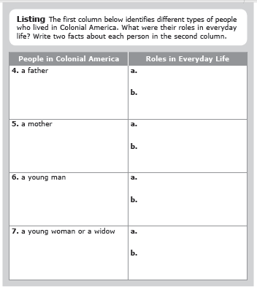 | Exit Slip  3: List 3 things you learned today  2: Explain 2 ways you contributed to class today  1: identify at least one question you still have. | Exit Slip  3: List 3 things you learned today  2: Explain 2 ways you contributed to class today  1: identify at least one question you still have. | Exit Slip  3: List 3 things you learned today  2: Explain 2 ways you contributed to class today  1: identify at least one question you still have.
Resources/Materials | No School  Labor Day | Computer  Projector  Student text books  Interactive journals  Colored pencils  Tape/glue  TE-online book | Computer  Projector  Student text books  Interactive journals  Colored pencils  Tape/glue  TE-online book | Computer  Projector  Student text books  Interactive journals  Colored pencils  Tape/glue  TE-online book | Computer  Projector  Student text books  Interactive journals  Colored pencils  Tape/glue  TE-online book
Projected Assessments | No School  Labor Day | Chapter 4: Life in the American Colonies (1607-1770)  - Vocabulary: Friday, September11 (no outside resources)  - Chapter Assessment: Tuesday, September 15 (allowed to create and use “cheat chard”) | Chapter 4: Life in the American Colonies (1607-1770)  - Vocabulary: Friday, September11 (no outside resources)  - Chapter Assessment: Tuesday, September 15 (allowed to create and use “cheat chard”) | Chapter 4: Life in the American Colonies (1607-1770)  - Vocabulary: Friday, September11 (no outside resources)  - Chapter Assessment: Tuesday, September 15 (allowed to create and use “cheat chard”) | Chapter 4: Life in the American Colonies (1607-1770)  - Vocabulary: Friday, September11 (no outside resources)  - Chapter Assessment: Tuesday, September 15 (allowed to create and use “cheat chard”)
Additional notes/ Upcoming Events | No School  Labor Day | Please make sure you are reviewing your notes from your interactive notebook each night.  Make sure to sign up for REMIND with Mrs. Stafford | Please make sure you are reviewing your notes from your interactive notebook each night.  Make sure to sign up for REMIND with Mrs. Stafford | Please make sure you are reviewing your notes from your interactive notebook each night.  Make sure to sign up for REMIND with Mrs. Stafford | Please make sure you are reviewing your notes from your interactive notebook each night.  Make sure to sign up for REMIND with Mrs. Stafford

