Teacher | Rachel Stafford
Class | 8th United States History

 | Date:  Mon., September 21 | Date:  Tues., September 22 | Date:  Wed. September 23 | Date:  Thurs, September 24 | Date:  Fri., September 25
Standard | TN Core Standards  - 8.22 Analyze the social, political and economic causes of the American Revolution and the major battles, leaders and events. | TN Core Standards  - 8.22 Analyze the social, political and economic causes of the American Revolution and the major battles, leaders and events. | TN Core Standards  8.22 Analyze the social, political and economic causes of the American Revolution and the major battles, leaders and events.  . | TN Core Standards  - 8.22 Analyze the social, political and economic causes of the American Revolution and the major battles, leaders and events. | TN Core Standards  - 8.22 Analyze the social, political and economic causes of the American Revolution and the major battles, leaders and events.
Objective  I can….. | Development of a New Nation  1720-1787  I can understand the major events preceding the founding of the nation and relate their significance to the development of American Republic. | Development of a New Nation  1720-1787  I can understand the major events preceding the founding of the nation and relate their significance to the development of American Republic. | Development of a New Nation  1720-1787  I can understand the major events preceding the founding of the nation and relate their significance to the development of American Republic. | Development of a New Nation  1720-1787  I can understand the major events preceding the founding of the nation and relate their significance to the development of American Republic. | Development of a New Nation  1720-1787  I can understand the major events preceding the founding of the nation and relate their significance to the development of American Republic.
Connections to Prior Knowledge | - Turn in HW (DBQ)  - Class Discussion of difficult questions from CH. 3 Test. | Bell Work  - What are taxes? How do taxes influence your life? Your family?  - How are people’s reaction to taxes today similar to what colonists felt? | Bell Work  - What advantages did the British hope to gain by limiting westward settlements in 1763 | Bell Work  - Why did Boston colonists think the British soldiers had gone too far?
Guiding Questions | - What led to the Revolutionary War? What were the outcomes of the war?  - What colonists helped lead the formation of a new government? | - What led to the Revolutionary War? What were the outcomes of the war?  - What colonists helped lead the formation of a new government? | - What led to the Revolutionary War? What were the outcomes of the war?  - What colonists helped lead the formation of a new government? | - What led to the Revolutionary War? What were the outcomes of the war?  - What colonists helped lead the formation of a new government? | - What led to the Revolutionary War? What were the outcomes of the war?  - What colonists helped lead the formation of a new government?

Instructional Strategies  I do… | - Introduce annotation of text HW. | Power Point: Journal Notes (Trade Laws, Sugar Act, Stamp Act, Townsend Act) | Homework Discussion  Pages 61-64  Annotating Text | PowerPoint Discussion  - Tension in the streets  - The Boston Massacre  - Propaganda | PowerPoint Discussion  - Crisis in Boston  - A Tea Party  - The Intolerable Acts
Differentiated Tasks  We do … | Activity: Annotating Texts: Having a Conversation with the Work | Analyze 5 sentence paragraph  - What do these acts have in common?  - How was the Stamp Act different from the Sugar Act and the Townsend Act?  - Why might Britain have believed the colonists would accept the Townsend Act? | ***  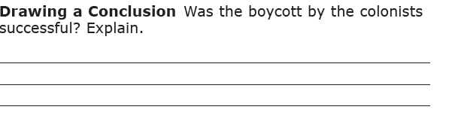  ***  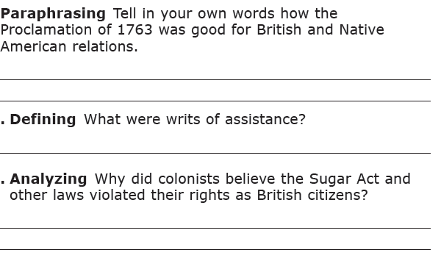***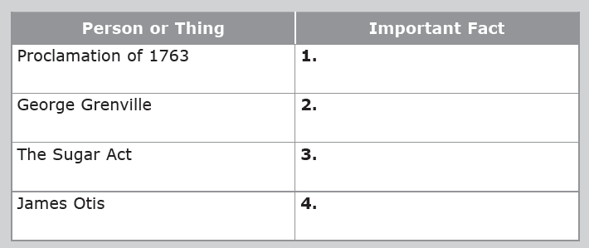 | ***True/False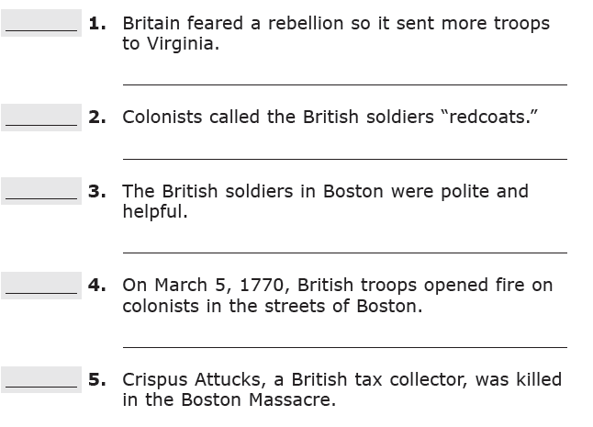  *** Text-Dependent Questions 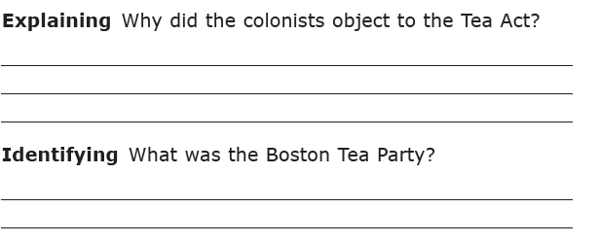  :*** Analyze the Outcome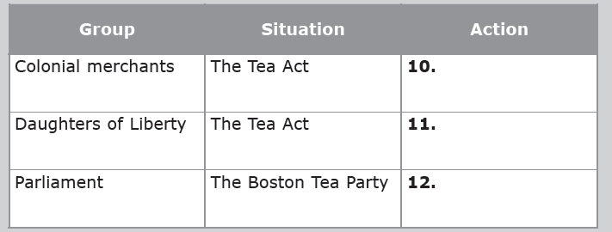 | Analyze 5 sentence paragraph  - What was the Boston Tea Party?  - Who owned the tea that was destroyed?  - Who threw it overboard?  - Why did they do this?
Assessment  They do …. | Begin Analysis of 5-1 homework passage (Due Wednesday, September 23) | 3-5 Sentence Journal Entry they Pair/Share  - Which changes in British policy do you think would have angered the colonist most? Why? | 3-5 Sentence Journal Entry they Pair/Share  - Why do you think Samuel Adams and others formed the Sons of Liberty instead of just acting alone to express their anger at the British policies? | 3-5 Sentence Journal Entry they Pair/Share  - How did the Boston Massacre affect British policies and relations between the two sides? | 3-5 Sentence Journal Entry they Pair/Share  - How did the British punish the colonists for the Boston Tea Party?
Homework | Complete Close Read Passage of 5-1 guided reading . (pages 61-64)  Follow annotating text directions and answer all questions. | Complete 5-lesson 1 homework portion. (pages 61-64) | Review Notes and homework. | Begin Homework Packet pages 65-68  Annotate appropriately | Finish Homework packet pages 65-68  Annotate appropriately
Closure | Exit Slip  3: List 3 things you learned today  2: Explain 2 ways you contributed to class today  1: identify at least one question you still have. | Exit Slip  3: List 3 things you learned today  2: Explain 2 ways you contributed to class today  1: identify at least one question you still have. | Exit Slip  3: List 3 things you learned today  2: Explain 2 ways you contributed to class today  1: identify at least one question you still have. | Exit Slip  3: List 3 things you learned today  2: Explain 2 ways you contributed to class today  1: identify at least one question you still have. | Exit Slip  3: List 3 things you learned today  2: Explain 2 ways you contributed to class today  1: identify at least one question you still have.
Resources/Materials | Computer  Projector  Student text books  Interactive journals  Colored pencils  Tape/glue  TE-online book | Computer  Projector  Student text books  Interactive journals  Colored pencils  Tape/glue  TE-online book | Computer  Projector  Student text books  Interactive journals  Colored pencils  Tape/glue  TE-online book | Computer  Projector  Student text books  Interactive journals  Colored pencils  Tape/glue  TE-online book | Computer  Projector  Student text books  Interactive journals  Colored pencils  Tape/glue  TE-online book
Projected Assessments | Chapter 5  - Mid-chapter quiz: Tuesday, Sept. 29  - Vocabulary Quiz: Monday, October 5  - Chapter Assessment: Thursday, October 8  - Writing Assignment: Friday, October 9 | Chapter 5  - Mid-chapter quiz: Tuesday, Sept. 29  - Vocabulary Quiz: Monday, October 5  - Chapter Assessment: Thursday, October 8  Writing Assignment: Friday, October 9 | Chapter 5  - Mid-chapter quiz: Tuesday, Sept. 29  - Vocabulary Quiz: Monday, October 5  - Chapter Assessment: Thursday, October 8  Writing Assignment: Friday, October 9 | Chapter 5  - Mid-chapter quiz: Tuesday, Sept. 29  - Vocabulary Quiz: Monday, October 5  - Chapter Assessment: Thursday, October 8  Writing Assignment: Friday, October 9 | Chapter 5  - Mid-chapter quiz: Tuesday, Sept. 29  - Vocabulary Quiz: Monday, October 5  - Chapter Assessment: Thursday, October 8  Writing Assignment: Friday, October 9
Additional notes/ Upcoming Events | Please make sure you are reviewing your notes from your interactive notebook each night.  Spirit Week This Week! | Please make sure you are reviewing your notes from your interactive notebook each night.  Spirit Week This Week! | Please make sure you are reviewing your notes from your interactive notebook each night.  Spirit Week This Week! | Please make sure you are reviewing your notes from your interactive notebook each night.  Spirit Week This Week! | Please make sure you are reviewing your notes from your interactive notebook each night.  Spirit Week This Week!  Middle School Dance 3:30-5.

