Teacher | Rachel Stafford
Class | 8th United States History

 | Date:  Mon., Sept. 14 | Date:  Tues., Sept. 15 | Date:  Wed. Sept. 16 | Date:  Thurs., Sept. 17 | Date:  Fri., Sept. 18
Standard | 8.12 Compare and contrast the day to day colonial life for men, women and children in different regions and of different ethnicities, including the systems of indentured servitude, as well as their connection to the land.  8.13 Analyze the ideas that significantly impacted the development of colonial self government by citing textual evidence and examining multiple perspectives. | 8.12 Compare and contrast the day to day colonial life for men, women and children in different regions and of different ethnicities, including the systems of indentured servitude, as well as their connection to the land.  8.13 Analyze the ideas that significantly impacted the development of colonial self government by citing textual evidence and examining multiple perspectives. | 8.12 Compare and contrast the day to day colonial life for men, women and children in different regions and of different ethnicities, including the systems of indentured servitude, as well as their connection to the land.  8.13 Analyze the ideas that significantly impacted the development of colonial self government by citing textual evidence and examining multiple perspectives. | 8.12 Compare and contrast the day to day colonial life for men, women and children in different regions and of different ethnicities, including the systems of indentured servitude, as well as their connection to the land.  8.13 Analyze the ideas that significantly impacted the development of colonial self government by citing textual evidence and examining multiple perspectives. | No School for Students  District Learning Day for Teachers
Objective  I can….. | I can  understand the social, political and economic reasons for the movement of people from Europe to the Americas, and they will describe the impact of colonization by Europeans on American Indians and on the development of the land that eventually became the United States of America. | I can  understand the social, political and economic reasons for the movement of people from Europe to the Americas, and they will describe the impact of colonization by Europeans on American Indians and on the development of the land that eventually became the United States of America. | I can  understand the social, political and economic reasons for the movement of people from Europe to the Americas, and they will describe the impact of colonization by Europeans on American Indians and on the development of the land that eventually became the United States of America. | I can  understand the social, political and economic reasons for the movement of people from Europe to the Americas, and they will describe the impact of colonization by Europeans on American Indians and on the development of the land that eventually became the United States of America. | No School for Students  District Learning Day for Teachers
Connections to Prior Knowledge | Whole Group:  Discuss the French and British influence in America.  Consider current places in the U.S. that reflect French and British influences and explain why you think that is so. | Bell work  Discussion of Focus Questions form Previous class.  - What issue sparked conflict between the British and the French in North America?  - Why was Fort Duquesne significant for the British?  - Why do you think colonist considered Washington a hero even though he lost the attack at Fort Necessity?  - Why did the Native Americas regard the British as a bigger threat than the French?  - When and where was the Albany Plan proposed?  - Who proposed it?  - What was its purpose?  - Why did the plan fail? | Bell work  Discussion of Questions  - Why were the attack and capture of Quebec a surprise to the French? What happened as a result?  - How did the signing of the treaty of Paris affect North America?  New Policies  - When colonist moved west of the Appalachian Mountains, where did they settle?  - How did Native American view the new settlers?  - Who was Pontiac? What happened during Pontiac’s War? How did the war end?  - How did the Proclamation of 1763 help the economy of Great Britain?  - How was the attitude of colonists towards British rule Changing?  - What other actions did the British take that angered colonists? | Bell Work  Write your answer as a complete statement, restating the question in your answer.  Why is the label the French and Indian war as it is a misleading documentation? | No School for Students  District Learning Day for Teachers
Guiding Questions | How do new ideas change the way people live? | What was the turning point in the French and Indian War? | How do new ideas change the way people live? | How do new ideas change the way people live? | No School for Students  District Learning Day for Teachers

Instructional Strategies  I do… | Whole Class Discussion of the New Albany Plan, Unite or Die political cartoon.  - How does the phrase “Unite or Die” relate to the segmented snake?  - What do the letters represent?  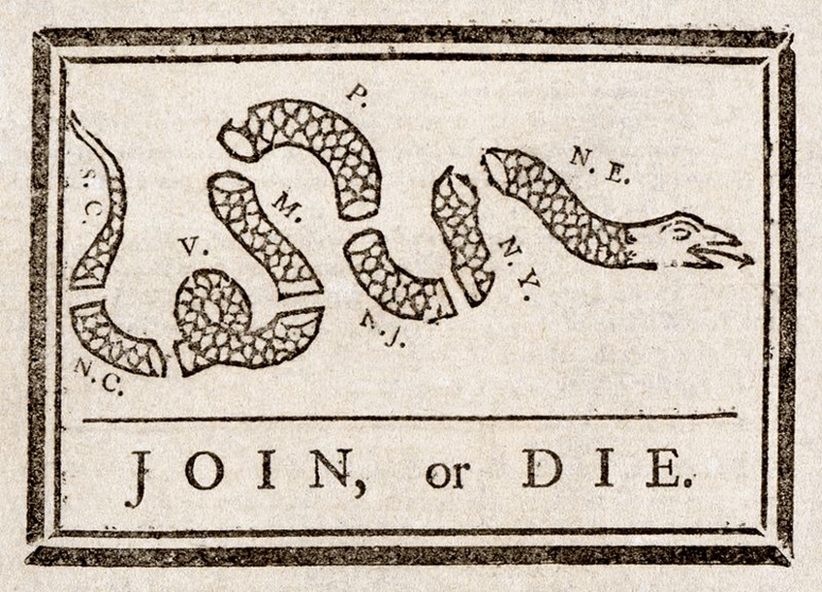 | PowerPoint presentation  Notes: The French And Indian War | Review Guiding Questions. P. 107  Whole group discussion. | Chapter 4 Assessment  Homework: Document Based Questions (DBQ) | No School for Students  District Learning Day for Teachers
Differentiated Tasks  We do … | Vocabulary Boxes  Great Awakening  Enlightenment  Iroquois Confederacy  Mercantilism  Middle Passage  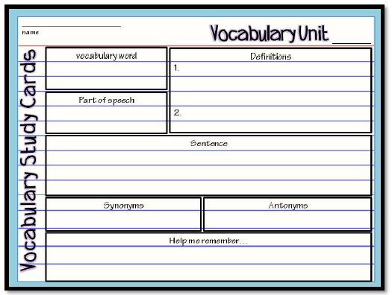 | Visual Skills Analysis p. 104  - What can you tell from the map about how the British attacked Montreal?  - What route did general Wolfe follow on his approach to Quebec?  - How did the signing of the Treaty of Paris affect North America? | Reflection Question  (Individual Assignment)  Review your interactive notebook and text to answer the following in a 5-8 sentence paragraph. Re-state the question in your topic sentence.  - How did the lives of the colonist change as events of the 17th and 18th centuries unfolded? | Chapter 4 Assessment  Homework: Document Based Questions (DBQ) | No School for Students  District Learning Day for Teachers
Assessment  They do …. | Focus Question:  (Text Dependent)  Rivalry Between Britain & France  - What issue sparked conflict between the British and the French in North America?  - Why was Fort Duquesne significant for the British?  - Why do you think colonist considered Washington a hero even though he lost the attack at Fort Necessity?  - Why did the Native Americas regard the British as a bigger threat than the French?  - When and where was the Albany Plan proposed?  - Who proposed it?  - What was its purpose?  - Why did the plan fail? | Focus Questions  (Text Dependent)  The French and Indian War  - Why were the attack and capture of Quebec a surprise to the French? What happened as a result?  - How did the signing of the treaty of Paris affect North America?  New Policies  - When colonist moved west of the Appalachian Mountains, where did they settle?  - How did Native American view the new settlers?  - Who was Pontiac? What happened during Pontiac’s War? How did the war end?  - How did the Proclamation of 1763 help the economy of Great Britain?  - How was the attitude of colonists towards British rule Changing?  - What other actions did the British take that angered colonists? | Chart Activity: List the main ideas and important details of the following groups.  Eng. Gov’t  Colonists  French  Settlers  Native  Am.  African  Am. | Chapter 4 Assessment  Homework: Document Based Questions (DBQ) | No School for Students  District Learning Day for Teachers
Closure | Exit Slip  3: List 3 things you learned today  2: Explain 2 ways you contributed to class today  1: identify at least one question you still have. | Exit Slip  3: List 3 things you learned today  2: Explain 2 ways you contributed to class today  1: identify at least one question you still have. | Exit Slip  3: List 3 things you learned today  2: Explain 2 ways you contributed to class today  1: identify at least one question you still have. | Exit Slip  3: List 3 things you learned today  2: Explain 2 ways you contributed to class today  1: identify at least one question you still have. | No School for Students  District Learning Day for Teachers
Resources/Materials | Computer  Projector  Student text books  Interactive journals  Colored pencils  Tape/glue  TE-online book | Computer  Projector  Student text books  Interactive journals  Colored pencils  Tape/glue  TE-online book | Computer  Projector  Student text books  Interactive journals  Colored pencils  Tape/glue  TE-online book | Computer  Projector  Student text books  Interactive journals  Colored pencils  Tape/glue  TE-online book | No School for Students  District Learning Day for Teachers
Projected Assessments | ***** Updated  Chapter 4: Life in the American Colonies (1607-1770)  Chapter Assessment: Thursday, Sept. 17 (allowed to create and use “cheat chard”) | ***** Updated  Chapter 4: Life in the American Colonies (1607-1770)  Chapter Assessment: Thursday, Sept. 17 (allowed to create and use “cheat chard”) | ***** Updated  Chapter 4: Life in the American Colonies (1607-1770)  Chapter Assessment: Thursday, Sept. 17 (allowed to create and use “cheat chard”) | ***** Updated  Chapter 4: Life in the American Colonies (1607-1770)  Chapter Assessment: Thursday, Sept. 17 (allowed to create and use “cheat chard”) | No School for Students  District Learning Day for Teachers
Additional notes/ Upcoming Events | Please make sure you are reviewing your notes from your interactive notebook each night.  Make sure to sign up for REMIND with Mrs. Stafford  ***** Parent Teacher Conference Night is Thursday. If you would like to schedule a conference please contact me by Wednesday, September 16 a5 8:30 am  staffordr@scsk12.org | Please make sure you are reviewing your notes from your interactive notebook each night.  Make sure to sign up for REMIND with Mrs. Stafford  ***** Parent Teacher Conference Night is Thursday. If you would like to schedule a conference please contact me by Wednesday, September 16 a5 8:30 am  staffordr@scsk12.org | Please make sure you are reviewing your notes from your interactive notebook each night.  Make sure to sign up for REMIND with Mrs. Stafford  ***** Parent Teacher Conference Night is Thursday. | Please make sure you are reviewing your notes from your interactive notebook each night.  Make sure to sign up for REMIND with Mrs. Stafford  ***** Parent Teacher Conference Night is Thursday. | No School for Students  District Learning Day for Teachers

