Teacher | Rachel Stafford
Class | 8th United States History

 | Date:  Mon., October 5 | Date:  Tues., October 6 | Date:  Wed. October 7 | Date:  Thurs, October 8 | Date:  Fri., October 9
Standard | TN Core Standards  - 8.22 Analyze the social, political and economic causes of the American Revolution and the major battles, leaders and events. | TN Core Standards  - 8.22 Analyze the social, political and economic causes of the American Revolution and the major battles, leaders and events. | TN Core Standards  8.22 Analyze the social, political and economic causes of the American Revolution and the major battles, leaders and events.  . | TN Core Standards  - 8.22 Analyze the social, political and economic causes of the American Revolution and the major battles, leaders and events. | TN Core Standards  - 8.22 Analyze the social, political and economic causes of the American Revolution and the major battles, leaders and events.
Objective  I can….. | Development of a New Nation  1720-1787  I can understand the major events preceding the founding of the nation and relate their significance to the development of American Republic. | Development of a New Nation  1720-1787  I can understand the major events preceding the founding of the nation and relate their significance to the development of American Republic. | Development of a New Nation  1720-1787  I can understand the major events preceding the founding of the nation and relate their significance to the development of American Republic. | Development of a New Nation  1720-1787  I can understand the major events preceding the founding of the nation and relate their significance to the development of American Republic. | Development of a New Nation  1720-1787  I can understand the major events preceding the founding of the nation and relate their significance to the development of American Republic.
Connections to Prior Knowledge | Bell Work  - Vocabulary Review | Bell Work  - How were the results of the battle of Lexington different from the results at Concord? | Bell Work  - Who did the most to promote the cause of Independence: George Washington, Thomas Jefferson, or Thomas Paine. Give reasons for your choice, | Bell Work  - Whose ideas inspired Jefferson? What were John Locke’s Ideas? | Bell Work  - How does the Declaration of Independence describe what is happening in the colonies at this point in history?
Guiding Questions | - What led to the Revolutionary War? What were the outcomes of the war?  - What colonists helped lead the formation of a new government? | - What led to the Revolutionary War? What were the outcomes of the war?  - What colonists helped lead the formation of a new government? | - What led to the Revolutionary War? What were the outcomes of the war?  - What colonists helped lead the formation of a new government? | - What led to the Revolutionary War? What were the outcomes of the war?  - What colonists helped lead the formation of a new government? | - What led to the Revolutionary War? What were the outcomes of the war?  - What colonists helped lead the formation of a new government?

Instructional Strategies  I do… | - Vocabulary Quiz Chapter 5 | PowerPoint notes  - The Declaration of Independence  - Writing  - Declaring | Discuss Lesson 4 HW  Turn in Homework Packet  Review Chapter 5  p. 135-136 | Chapter 5 Assessment  Cheat Card Allowed | Evaluate 3 peer’s writing assignments  - Using teacher supplied rubric
Differentiated Tasks  We do … | Vocabulary Quiz Chapter 5 |  | 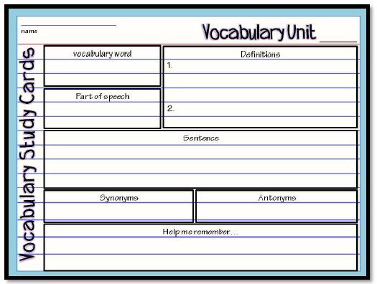  Continental Congress  Olive Branch Petition  Declaration of Independence | Chapter 5 Assessment  Cheat Card Allowed | Evaluate 3 peer’s writing assignments  - Using teacher supplied rubric  Document Based Assessment (DBQ)
Assessment  They do …. | Vocabulary Quiz Chapter 5  - What Do You Think Analysis p. 126-127 | 3-5 Sentence Journal Entry they Pair/Share  - What grievances against King George III were included in the Declaration of Independence? | 3-5 Sentence Journal Entry they Pair/Share  - What were the key issues that led to the conflict between Britain and the American colonies? | 3-5 Sentence Journal Entry they Pair/Share  - How did the Geographic distance between Britain and the colonies lead to conflict? | 3-5 Sentence Journal Entry they Pair/Share  - Why do you think mutually was inserted into the last sentence of the Declaration of Independence?
Homework | - Extra Credit Due Tomorrow  - HW packet Lesson 4 Due Wednesday  - Chapter 5 Test is Thursday  - Typed writing assignment is due Friday | - HW packet Lesson 4 Due Wednesday  - Chapter 5 Test is Thursday  - Typed writing assignment is due Friday | - Chapter 5 Test is Thursday  - Typed writing assignment is due Friday | Typed writing assignment is due Friday
Closure | Exit Slip  3: List 3 things you learned today  2: Explain 2 ways you contributed to class today  1: identify at least one question you still have. | Exit Slip  3: List 3 things you learned today  2: Explain 2 ways you contributed to class today  1: identify at least one question you still have. | Exit Slip  3: List 3 things you learned today  2: Explain 2 ways you contributed to class today  1: identify at least one question you still have. | Exit Slip  3: List 3 things you learned today  2: Explain 2 ways you contributed to class today  1: identify at least one question you still have. | Exit Slip  3: List 3 things you learned today  2: Explain 2 ways you contributed to class today  1: identify at least one question you still have.
Resources/Materials | Computer  Projector  Student text books  Interactive journals  Colored pencils  Tape/glue  TE-online book | Computer  Projector  Student text books  Interactive journals  Colored pencils  Tape/glue  TE-online book | Computer  Projector  Student text books  Interactive journals  Colored pencils  Tape/glue  TE-online book | Computer  Projector  Student text books  Interactive journals  Colored pencils  Tape/glue  TE-online book | Computer  Projector  Student text books  Interactive journals  Colored pencils  Tape/glue  TE-online book
Projected Assessments | Chapter 5  - Vocabulary Quiz: Monday, October 5  - Chapter Assessment: Thursday, October 8  - Writing Assignment: Friday, October 9 | Chapter 5  - Chapter Assessment: Thursday, October 8  - Writing Assignment: Friday, October 9 | Chapter 5  - Chapter Assessment: Thursday, October 8  - Writing Assignment: Friday, October 9 | Chapter 5  - Thursday, October 8  - Writing Assignment: Friday, October 9
Additional notes/ Upcoming Events | Please make sure you are reviewing your notes from your interactive notebook each night. | Please make sure you are reviewing your notes from your interactive notebook each night. | Please make sure you are reviewing your notes from your interactive notebook each night. | Please make sure you are reviewing your notes from your interactive notebook each night. | Please make sure you are reviewing your notes from your interactive notebook each night.

