Teacher | Rachel Stafford
Class | 8th United States History

 | Date:  Mon., February 1 | Date:  Tues., February 2 | Date:  Wed. February 3 | Date:  Thurs, February 4 | Date:  Fri., February 5
Standard | TN Core Standards  8.40 Analyze the role played by John Marshall in strengthening the central government, including the key decisions of the Supreme Court - Marbury v. Madison, Gibbons v. Ogden, and McCulloch v. Maryland. (H, P)  8.41 Explain the major events of Thomas Jefferson’s presidency, including his election in 1800, Louisiana Purchase, the defeat of the Barbary pirates, and the Embargo Act. (E, G, H)  8.42 Analyze the impact of the Lewis and Clark Expedition by identifying the routes on a map, citing evidence from their journals. (C, E, G, H) | TN Core Standard  8.20 Explain the impact of individuals who created interest in the land west of the Appalachian Mountains, including:  - Long hunters  - Wilderness Road  - Daniel Boone  - William Bean  - Thomas Sharpe  - Dr. Thomas Walker | TN Core Standard  8.20 Explain the impact of individuals who created interest in the land west of the Appalachian Mountains, including:  - Long hunters  - Wilderness Road  - Daniel Boone  - William Bean  - Thomas Sharpe  - Dr. Thomas Walker | TN Core Standard  8.20 Explain the impact of individuals who created interest in the land west of the Appalachian Mountains, including:  - Long hunters  - Wilderness Road  - Daniel Boone  - William Bean  - Thomas Sharpe  - Dr. Thomas Walker | TN Core Standard  8.20 Explain the impact of individuals who created interest in the land west of the Appalachian Mountains, including:  - Long hunters  - Wilderness Road  - Daniel Boone  - William Bean  - Thomas Sharpe  - Dr. Thomas Walker
Objective  I can….. | The Jefferson Era  (Chapter 10)  I can analyze the aspirations and ideals of the people of the new nation. | Growth & Expansion  (Chapter 11)  I can analyze the aspirations and ideals of the people of the new nation. | Growth & Expansion  (Chapter 11)  I can analyze the aspirations and ideals of the people of the new nation. | Growth & Expansion  (Chapter 11)  I can analyze the aspirations and ideals of the people of the new nation. | Growth & Expansion  (Chapter 11)  I can analyze the aspirations and ideals of the people of the new nation.
Connections to Prior Knowledge | Bell Work:  - Review chapter 10  - Discuss and turn review sheet  - Turn in War of 1812 Map Activity | Bell Work:  How do you think the innovations of the 1700s revolution affected people? Did they affect people more or less that today’s changes? | Bell Work:  Discuss 11-1 Text Dependent Questions | Bell Work:  Discuss 11-2 Text Dependent Questions | Bell Work:  Discuss 11-3 Text Dependent Questions
Guiding Questions | - How does geography influence the way people live?  - Why does conflict develop? | - How does geography influence the way people live?  - Why does conflict develop? | - How does geography influence the way people live?  - Why does conflict develop? | - How does geography influence the way people live?  - Why does conflict develop? | - How does geography influence the way people live?  - Why does conflict develop?

Instructional Strategies  I do… | Complete Chapter 10 Test  - Cheat Card Allowed  - After, complete chapter 11 pre-test | Notes  Lesson 1: A Growing Economy  Industrial Growth  - The Industrial Revolution in the US  - New Inventions  - The Rise of Factories  - Free Enterprise  Agriculture Grows  Economic Independence  - Growth of Corporations  - Cities Grow Up | Notes  Lesson 2: Moving West  Headed West  - Daniel Boone and the Wilderness Road  - Building Roadways  - Traveling on Rivers  - The Clermont’s First Voyage  - New Waterways  - The Erie Canal  - Canal Travel Expands  The Move West Continues | Notes  Lesson 3: Unity & Sectionalism  National Unity  - Henry Clay’s American System  - The Second Bank of the US  - Competition from Britain  - New Tariffs  - Growing Sectionalism  - Nationalism and the Supreme Court  - MO Statehood  - The MO Compromise  Foreign Affairs  - Relations with Britain  - Relations with Spain  - Spain Loses Power  - The Monroe Doctrine | Complete Chapter 11 Test  - Cheat Card Allowed  - Will consist of vocabulary and chapter questions
Differentiated Tasks  We do … | Complete Chapter 10 Test  - Cheat Card Allowed  - After, complete chapter 11 pre-test | Text Dependent Questions  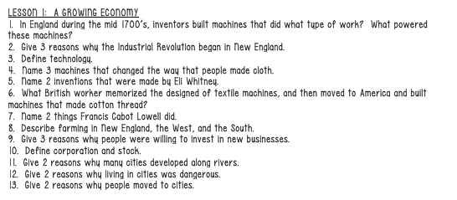 | Text Dependent Questions  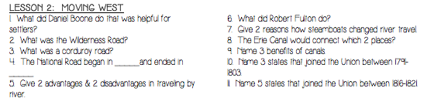 | Text Dependent Questions  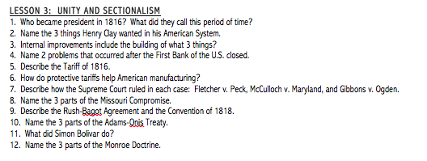 | Complete Chapter 11 Test  - Cheat Card Allowed  - Will consist of vocabulary and chapter questions
Assessment  They do …. | Complete Chapter 10 Test  - Cheat Card Allowed  - After, complete chapter 11 pre-test | How did industrialization affect the way people lived in the United States? | What did Americans do in the late 1700s and early 1800s to improve the movement of people and goods? | What issues divided the country at the end of the Era of good feelings?  How did the US role in the world change in the early 1800s? | Complete Chapter 11 Test  - Cheat Card Allowed  - Will consist of vocabulary and chapter questions
Homework | Homework will be completed through text-dependent alaysis questions at the end of each section. Student will turn in the cumulative work prior to the test on Friday | Homework will be completed through text-dependent alaysis questions at the end of each section. Student will turn in the cumulative work prior to the test on Friday | Homework will be completed through text-dependent alaysis questions at the end of each section. Student will turn in the cumulative work prior to the test on Friday | Homework will be completed through text-dependent alaysis questions at the end of each section. Student will turn in the cumulative work prior to the test on Friday
Closure | Exit Slip  3: List 3 things you learned today  2: Explain 2 ways you contributed to class today  1: identify at least one question you still have. | Exit Slip  3: List 3 things you learned today  2: Explain 2 ways you contributed to class today  1: identify at least one question you still have. | Exit Slip  3: List 3 things you learned today  2: Explain 2 ways you contributed to class today  1: identify at least one question you still have. | Exit Slip  3: List 3 things you learned today  2: Explain 2 ways you contributed to class today  1: identify at least one question you still have. | Exit Slip  3: List 3 things you learned today  2: Explain 2 ways you contributed to class today  1: identify at least one question you still have.
Resources/Materials | Computer  Projector  Student text books  Interactive journals  Colored pencils  Tape/glue  TE-online book | Computer  Projector  Student text books  Interactive journals  Colored pencils  Tape/glue  TE-online book | Exit Slip  3: List 3 things you learned today  2: Explain 2 ways you contributed to class today  1: identify at least one question you still have. | Computer  Projector  Student text books  Interactive journals  Colored pencils  Tape/glue  TE-online book | Computer  Projector  Student text books  Interactive journals  Colored pencils  Tape/glue  TE-online book
Projected Assessments |  | Chapter 11  Test is Friday, February 5  Cheat Card Allowed  Will combine vocabulary and chapter questions in the same assessment. | Chapter 11  Test is Friday, February 5  Cheat Card Allowed  Will combine vocabulary and chapter questions in the same assessment. | Chapter 11  Test is Friday, February 5  Cheat Card Allowed  Will combine vocabulary and chapter questions in the same assessment.
Additional notes/ Upcoming Events | Please make sure you are reviewing your notes from your interactive notebook each night. | Please make sure you are reviewing your notes from your interactive notebook each night. | Please make sure you are reviewing your notes from your interactive notebook each night. | Please make sure you are reviewing your notes from your interactive notebook each night. | Please make sure you are reviewing your notes from your interactive notebook each night.

