Teacher | Rachel Stafford
Class | 8th United States History

 | Date:  Mon., August 21 | Date:  Tues., September 1 | Date:  Wed. September 2 | Date:  Thurs, September 3 | Date:  Fri., September 4
Standard | 8.10 Locate and identify the first 13 colonies describing how their location and geographic features influenced their development. | 8.14 Identify the origins and development of slavery in the colonies, overt and passive resistance to enslavement and the Middle Passage. | 8.14 Identify the origins and development of slavery in the colonies, overt and passive resistance to enslavement and the Middle Passage.  . | 8.12 Compare and contrast the day to day colonial life for men, women and children in different regions and of different ethnicities, including the systems of indentured servitude, as well as their connection to the land.  8.13 Analyze the ideas that significantly impacted the development of colonial self government by citing textual evidence and examining multiple perspectives. | 8.10 Locate and identify the first 13 colonies describing how their location and geographic features influenced their development.  8.12 Compare and contrast the day to day colonial life for men, women and children in different regions and of different ethnicities, including the systems of indentured servitude, as well as their connection to the land.  8.13 Analyze the ideas that significantly impacted the development of colonial self government by citing textual evidence and examining multiple perspectives.  8.14 Identify the origins and development of slavery in the colonies, overt and passive resistance to enslavement and the Middle Passage
Objective  I can….. | I can  understand the social, political and economic reasons for the movement of people from Europe to the Americas, and they will describe the impact of colonization by Europeans on American Indians and on the development of the land that eventually became the United States of America. | I can  understand the social, political and economic reasons for the movement of people from Europe to the Americas, and they will describe the impact of colonization by Europeans on American Indians and on the development of the land that eventually became the United States of America. | I can  understand the social, political and economic reasons for the movement of people from Europe to the Americas, and they will describe the impact of colonization by Europeans on American Indians and on the development of the land that eventually became the United States of America. | I can  understand the social, political and economic reasons for the movement of people from Europe to the Americas, and they will describe the impact of colonization by Europeans on American Indians and on the development of the land that eventually became the United States of America. | I can  understand the social, political and economic reasons for the movement of people from Europe to the Americas, and they will describe the impact of colonization by Europeans on American Indians and on the development of the land that eventually became the United States of America.
Connections to Prior Knowledge | Textbook p. 81: The Story Matters  - Read as a class  - How are Pilgrims depicted?  - How does this portrait differ from the usual picture of Pilgrims?  - Based om this portrait and passage, what did Elizabeth Freake value in her life?  - Which of these values would you say are commonly held by people in the United States today? | Bell work  Journal  3-5 sentence  Describe the economy of the region where we live. | Bell work  What was the Middle Passage? | Bell work  Read (Project) the first sentence of the US Constitution.  - Ask students if they recognize it.  - If no, explain that it is the beginning of the Constitution, which established the US government.  - Explain that students will be learning about ideas that formed the basis of government in Great Britain and the colonies. | Bell work  - What was the Glorious Revolution and how did it begin?  - Why was the English Bill of Rights written?
Guiding Questions | How does geography influence the way people live? | How does geography influence the way people live?  - How did the economic activity of the three regions reflect their geography?  - Why were enslaved Africans brought to the colonies? | How does geography influence the way people live?  - How did the economic activity of the three regions reflect their geography?  - Why were enslaved Africans brought to the colonies? | How does geography influence the way people live?  - Why are protected rights and representative government important principles?  - How did the colonists react to England’s economic polices? | How does geography influence the way people live?  - How did the economic activity of the three regions reflect their geography?  - Why were enslaved Africans brought to the colonies?  - How did the colonists react to England’s economic polices?

Instructional Strategies  I do… | Map & Timeline Skills p. 82-83  - Map Skills 1-3  - Recall and point out where the earliest English settlers arrived in North America and explain what happened to those colonists.  - Which events on the timeline might effect life in the English colonies during this period? | Lesson 1: A New Faith  - Key Terms  - Powerpoint of new information  - Notes  - Making a Living in the Colonies  - The Growth of Slavery | - Continuation of previous lesson  - The Growth of Slavery | Continue with previous lesson  - Notes  - Key Terms  - Learning check: What do you know  - English Principles of Government  - English Economic Policies | Whole class Review
Differentiated Tasks  We do … | Pair/Share  - Write one, two, or three questions about the map and the timeline.  - Briefly discuss the possible answers to your questions.  - Be prepared to share one of your questions and answer to the class | Pair/Share  Use the book to answer the following text analysis questions.  - How did the soil quality and climate in the Middle Colonies affect the development of farming there?  - How did farming conditions lead to the development of other industries in New England?  - Why do you think the large plantations developed in the Tidewater rather than the backcountry? | - Close Read Activity  - Read, answer MC questions, highlight answers in the text, and one constructed response in a 5-8 sentence paragraph  - Beginning of Slavery in the Colonies  - Slave Economy  - Middle Passage | Individual work  English Principles of Government Chart  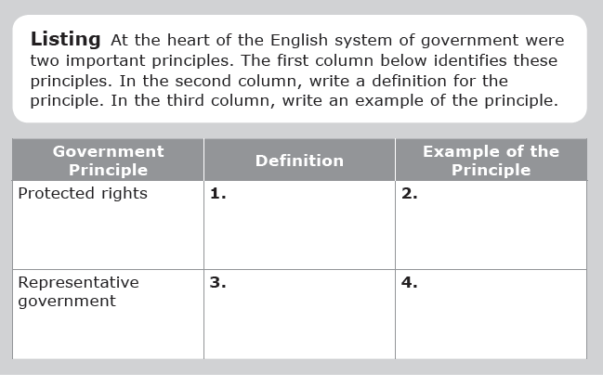  Economic Polices  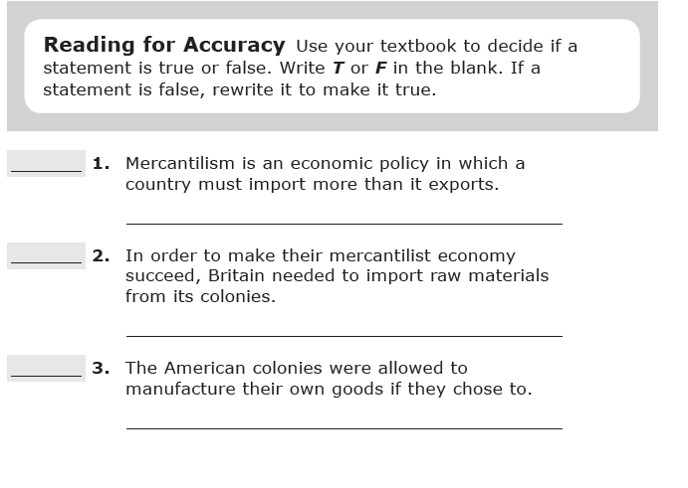  Analyzing Text  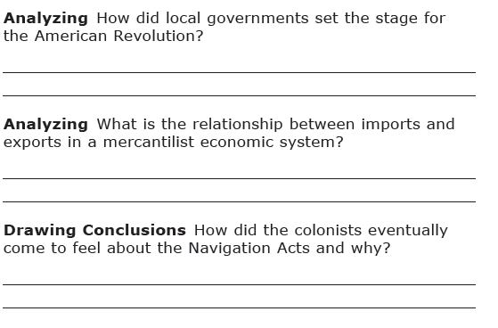 | Individual assessment:  - Life in the American Colonies - Mid-chapter quiz
Assessment  They do …. | 3-5 sentence journal entry  - Why do you think the New England colonies developed industries that were not based on agriculture. | journal entry  - Why were New England farmers unable to grow cash crops?  - Why were enslaves Africans brought to the colonies? | 3-5 sentence journal entry  Why would Quakers object to slavery? | Focus Questions  - How do people benefit from limited government?  - Why did colonists begin smuggling goods into and out of the colonies? | Individual assessment:  Life in the American Colonies- Mid-chapter quiz  After Quiz Activity: Slave Narratives
Closure | Exit Slip  3: List 3 things you learned today  2: Explain 2 ways you contributed to class today  1: identify at least one question you still have. | Exit Slip  3: List 3 things you learned today  2: Explain 2 ways you contributed to class today  1: identify at least one question you still have. | Exit Slip  3: List 3 things you learned today  2: Explain 2 ways you contributed to class today  1: identify at least one question you still have. | Exit Slip  3: List 3 things you learned today  2: Explain 2 ways you contributed to class today  1: identify at least one question you still have. | Exit Slip  3: List 3 things you learned today  2: Explain 2 ways you contributed to class today  1: identify at least one question you still have.
Resources/Materials | Computer  Projector  Student text books  Interactive journals  Colored pencils  Tape/glue  TE-online book | Computer  Projector  Student text books  Interactive journals  Colored pencils  Tape/glue  TE-online book | Computer  Projector  Student text books  Interactive journals  Colored pencils  Tape/glue  TE-online book | Computer  Projector  Student text books  Interactive journals  Colored pencils  Tape/glue  TE-online book | Computer  Projector  Student text books  Interactive journals  Colored pencils  Tape/glue  TE-online book
Projected Assessments | Chapter 4: Life in the American Colonies (1607-1770)  - Mid-chapter Quiz: Friday, September 4 (open journal)  - Vocabulary: Friday, September11 (no outside resources)  - Chapter Assessment: Tuesday, September 15 (allowed to create and use “cheat chard”) | Chapter 4: Life in the American Colonies (1607-1770)  - Mid-chapter Quiz: Friday, September 4 (open journal)  - Vocabulary: Friday, September11 (no outside resources)  - Chapter Assessment: Tuesday, September 15 (allowed to create and use “cheat chard”) | Chapter 4: Life in the American Colonies (1607-1770)  - Mid-chapter Quiz: Friday, September 4 (open journal)  - Vocabulary: Friday, September11 (no outside resources)  - Chapter Assessment: Tuesday, September 15 (allowed to create and use “cheat chard”) | Chapter 4: Life in the American Colonies (1607-1770)  - Mid-chapter Quiz: Friday, September 4 (open journal)  - Vocabulary: Friday, September11 (no outside resources)  - Chapter Assessment: Tuesday, September 15 (allowed to create and use “cheat chard”) | Chapter 4: Life in the American Colonies (1607-1770)  - Mid-chapter Quiz: Friday, September 4 (open journal)  - Vocabulary: Friday, September11 (no outside resources)  - Chapter Assessment: Tuesday, September 15 (allowed to create and use “cheat chard”)
Additional notes/ Upcoming Events | Please make sure you are reviewing your notes from your interactive notebook each night. | Please make sure you are reviewing your notes from your interactive notebook each night. | Please make sure you are reviewing your notes from your interactive notebook each night. | Please make sure you are reviewing your notes from your interactive notebook each night. | Please make sure you are reviewing your notes from your interactive notebook each night.

