Teacher | Rachel Stafford
Class | 8th United States History

 | Date:  Mon., April 25 | Date:  Tues., April 26 | Date:  Wed. April 27 | Date:  Thurs, April 28 | Date:  Fri., April 29
Standard | TN Core Standards  - 8.72 Identify on a map the boundaries constituting the North and the South and delineate and evaluate the geographical differences between the two regions, including the differences between agrarians and industrialists. (E, G, P)  - 8.73 Describe the influence of industrialization and technological developments of the regions, including human modification of the landscape and how physical geography shaped human actions-growth of cities, deforestation, farming and mineral extraction. (E, G, H, P)  - 8.76 Describe Abraham Lincoln’s presidency and his significant writings and speeches, including his House Divided speech in 1858, Gettysburg Address in 1863, Emancipation Proclamation in 1863 and inaugural addresses in 1861 and 1865. (C, H, P)  - (C, E, H, P, TN)  - 8.80 Trace the critical developments and events in the war, including geographical advantages and economic advantages of both sides, technological advances and the location and significance of the following battles:  - 8.81 Assess the impact of the assassination of President Abraham Lincoln on both the North and the South. (C, E, H, P) | TN Core Standards  - 8.72 Identify on a map the boundaries constituting the North and the South and delineate and evaluate the geographical differences between the two regions, including the differences between agrarians and industrialists. (E, G, P)  - 8.73 Describe the influence of industrialization and technological developments of the regions, including human modification of the landscape and how physical geography shaped human actions-growth of cities, deforestation, farming and mineral extraction. (E, G, H, P)  - 8.76 Describe Abraham Lincoln’s presidency and his significant writings and speeches, including his House Divided speech in 1858, Gettysburg Address in 1863, Emancipation Proclamation in 1863 and inaugural addresses in 1861 and 1865. (C, H, P)  - (C, E, H, P, TN)  - 8.80 Trace the critical developments and events in the war, including geographical advantages and economic advantages of both sides, technological advances and the location and significance of the following battles:  - 8.81 Assess the impact of the assassination of President Abraham Lincoln on both the North and the South. (C, E, H, P) | TN Core Standards  - 8.82 Explain the significance of 13th, 14th and 15th Amendments to the U.S. Constitution. (P)  - 8.83 Analyze the choice of Andrew Johnson as Vice-President, his succession to the Presidency, his plan for Reconstruction and his conflict with the Radical Republicans. (H, P, TN) | TN Core Standards  - TN Core Standards will vary due to needs of the class and activities. | TN Core Standards  - TN Core Standards will vary due to needs of the class and activities.
Objective  I can….. | The Civil War  (Chapter 17)  1861-1865  I can analyze the multiple causes, key events, and complex consequences of the Civil War. | The Civil War  (Chapter 17)  1861-1865  I can analyze the multiple causes, key events, and complex consequences of the Civil War. | Reconstruction  (Chapter 18)  1865-1877  I can analyze the character and lasting consequences of Reconstruction.. | TN Ready Prep And Review | TN Ready Prep And Review
Connections to Prior Knowledge | Bell Work:  Why did General Lee finally surrender? | Bell Work:  Map the battles discussed in class.  - red for confederacy  - blue for union | Bell Work:  What do you know about Lincoln’s Assassination? | TN Ready Prep And Review | TN Ready Prep And Review
Guiding Questions | Why does conflict develop? | Chapter 17 Assessment | Why does conflict develop? | TN Ready Prep And Review | TN Ready Prep And Review

Instructional Strategies  I do… | - Chapter 17 Review  - Article/Close-read Summary  - Create Cheat Card | Chapter 17 Assessment | Background on the beginning Days of Reconstruction.  -Lincoln’s Plan  Lincoln’s Assassination  Johnson’s Plan | - TN Ready Prep And Review | - TN Ready Prep And Review
Differentiated Tasks  We do … | Entrench  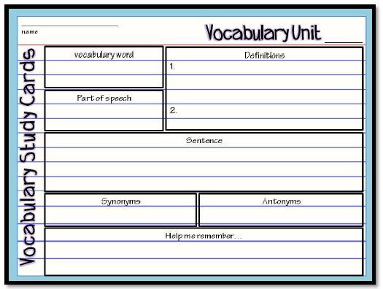 | Chapter 17 Assessment | Close Read: Reconstruction | TN Ready Prep And Review | TN Ready Prep And Review
Assessment  They do …. | Union Victories Confederate Victories | Chapter 17 Assessment | Close Read Vocabulary Break Down | TN Ready Prep And Review | TN Ready Prep And Review
Homework
Closure | Exit Slip  3: List 3 things you learned today  2: Explain 2 ways you contributed to class today  1: identify at least one question you still have. | Exit Slip  3: List 3 things you learned today  2: Explain 2 ways you contributed to class today  1: identify at least one question you still have. | Exit Slip  3: List 3 things you learned today  2: Explain 2 ways you contributed to class today  1: identify at least one question you still have. | Exit Slip  3: List 3 things you learned today  2: Explain 2 ways you contributed to class today  1: identify at least one question you still have. | Exit Slip  3: List 3 things you learned today  2: Explain 2 ways you contributed to class today  1: identify at least one question you still have.
Resources/Materials | Computer  Projector  Student text books  Interactive journals  Colored pencils  Tape/glue  TE-online book | Computer  Projector  Student text books  Interactive journals  Colored pencils  Tape/glue  TE-online book | Exit Slip  3: List 3 things you learned today  2: Explain 2 ways you contributed to class today  1: identify at least one question you still have. | Computer  Projector  Student text books  Interactive journals  Colored pencils  Tape/glue  TE-online book | Computer  Projector  Student text books  Interactive journals  Colored pencils  Tape/glue  TE-online book
Projected Assessments | Chapter 17 Assessments  - Mid- Chapter Quiz: Friday, April 15 (open journal)  - Vocabulary Quiz: Friday, April 22 (no outside resources  - Test: Tuesday, April 26 (cheat Card Allowed)
Additional notes/ Upcoming Events | Please make sure you are reviewing your notes from your interactive notebook each night. | Please make sure you are reviewing your notes from your interactive notebook each night. | Please make sure you are reviewing your notes from your interactive notebook each night. | Please make sure you are reviewing your notes from your interactive notebook each night. | Please make sure you are reviewing your notes from your interactive notebook each night.

