Teacher | Rachel Stafford
Class | 7th World History

 | Date:  Mon., September 21 | Date:  Tues., September 22 | Date:  Wed. September 23 | Date:  Thurs, September 24 | Date:  Fri., September 25
Standard | TN Core Standards  - 7.13 Analyze the growth of the kingdoms of Ghana, Mali and Songhai including trading centers such as Timbuktu and Jenne, which would later develop into centers of culture and learning. | TN Core Standards  - 7.13 Analyze the growth of the kingdoms of Ghana, Mali and Songhai including trading centers such as Timbuktu and Jenne, which would later develop into centers of culture and learning. | TN Core Standards  - 7.13 Analyze the growth of the kingdoms of Ghana, Mali and Songhai including trading centers such as Timbuktu and Jenne, which would later develop into centers of culture and learning.  . | TN Core Standards  - 7.13 Analyze the growth of the kingdoms of Ghana, Mali and Songhai including trading centers such as Timbuktu and Jenne, which would later develop into centers of culture and learning. | TN Core Standards  - 7.13 Analyze the growth of the kingdoms of Ghana, Mali and Songhai including trading centers such as Timbuktu and Jenne, which would later develop into centers of culture and learning.
Objective  I can….. | Africa - AD 400-1500  I can analyze the geographic, political, economic, social and religious structures of the civilizations. | Africa - AD 400-1500  I can analyze the geographic, political, economic, social and religious structures of the civilizations. | Africa - AD 400-1500  I can analyze the geographic, political, economic, social and religious structures of the civilizations. | Africa - AD 400-1500  I can analyze the geographic, political, economic, social and religious structures of the civilizations. | Africa - AD 400-1500  I can analyze the geographic, political, economic, social and religious structures of the civilizations.
Connections to Prior Knowledge | - Turn in HW (DBQ)  - Class Discussion of difficult questions from CH. 3 Test. | Bell Work  - How do you think Africa’s physical features affected trade in early Africa?  Turn in Africa Map | Bell Work  - What is one reason why Africa has such a varied geography? | Bell Work  - Who was the most important person in the founding pa Mali? Explain at least two contributions. | Bell Work  - Why did Axum become a prosperous trading center?
Guiding Questions | - How did the geography of the continent affect the development of kingdoms in Africa?  - What were the causes for the rise and fall of African trading empires? | - How did the geography of the continent affect the development of kingdoms in Africa?  - What were the causes for the rise and fall of African trading empires? | - How did the geography of the continent affect the development of kingdoms in Africa?  - What were the causes for the rise and fall of African trading empires? | - How did the geography of the continent affect the development of kingdoms in Africa?  - What were the causes for the rise and fall of African trading empires? | - How did the geography of the continent affect the development of kingdoms in Africa?  - What were the causes for the rise and fall of African trading empires?

Instructional Strategies  I do… | - Introduce annotation of text HW. | Power Point  - African Beginnings (landscape, grasslands, rivers)  - Trading Empires  - West Africa Beginnings | Review Power Point from yesterday, pulling out areas of concern | Power Point  - East African Kingdoms  - Coastal States  - The Rise of Zimbabwe  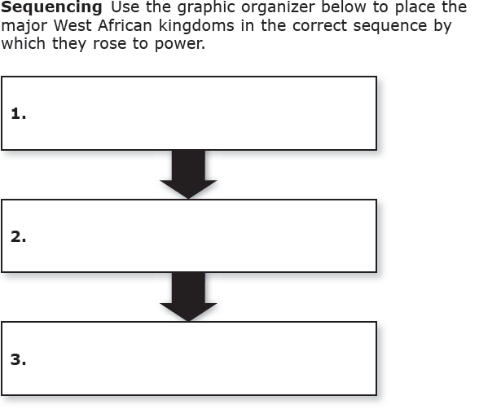 | Discussion of Homework Annotating Text  Review Information  Introduce reflective writing
Differentiated Tasks  We do … | Activity: Annotating Texts: Having a Conversation with the Work | Pair/Share Focus Questions  - How does the drier climate of the Sahel affect how people there live?  - What is the largest desert in Africa?  - How did Ghana’s location help it become a powerful trading empire?  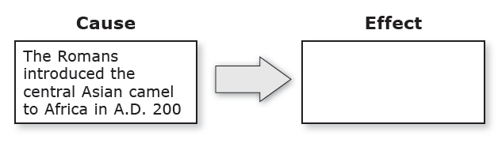  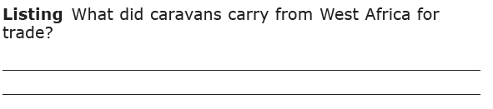 | Pair/Share  Textual Evidence: List the three major West African trading kingdoms, then list two products from each.  West Af. Kingdoms Product  Geography Connection  Which geographical features covers most of East Africa?  How might the geographic zones affected interactions among people?  Infographic analysis  List the largest rivers  Compare/contrst Africa to the US | Vocabulary Boxes  Griot  Dhow  Savanna  Plateau  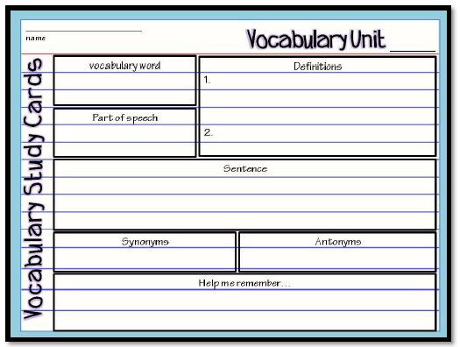 | 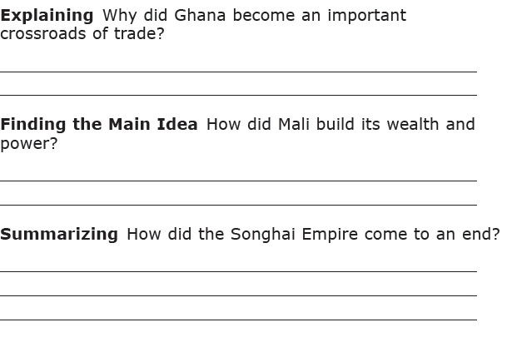
Assessment  They do …. | Begin Analysis of 6-1 homework passage (Due Friday, September 25) | 3-5 Sentence Journal Entry they Pair/Share  - Why were camels essential for the Sahara trade? | 3-5 Sentence Journal Entry they Pair/Share  - How is a savanna different from a plateau?  - List and describe the four main zones in Africa. | 3-5 Sentence Journal Entry they Pair/Share  - What unique factors allowed the East African trading kingdoms to expand their trade? | Narrative  - You live in Ancient West Africa. In a personal journal entry, describe what you might experience when you arrive in East Africa. Tell about the people, land and weather.
Homework | Africa map is due tomorrow  Read/Annotate Packet  p. 181-184- Due Friday (only pages 181-184 will be checked Friday. The packet is ongoing for the chapter) | Read/Annotate Packet  p. 181-184- Due Friday (only pages 181-184 will be checked Friday. The packet is ongoing for the chapter) | Review Notes and homework.  Read/Annotate Packet  p. 181-184- Due Friday (only pages 181-184 will be checked Friday. The packet is ongoing for the chapter) | Review Notes and homework.  Read/Annotate Packet  p. 181-184- Due Friday (only pages 181-184 will be checked Friday. The packet is ongoing for the chapter) | Review Notes
Closure | Exit Slip  3: List 3 things you learned today  2: Explain 2 ways you contributed to class today  1: identify at least one question you still have. | Exit Slip  3: List 3 things you learned today  2: Explain 2 ways you contributed to class today  1: identify at least one question you still have. | Exit Slip  3: List 3 things you learned today  2: Explain 2 ways you contributed to class today  1: identify at least one question you still have. | Exit Slip  3: List 3 things you learned today  2: Explain 2 ways you contributed to class today  1: identify at least one question you still have. | Exit Slip  3: List 3 things you learned today  2: Explain 2 ways you contributed to class today  1: identify at least one question you still have.
Resources/Materials | Computer  Projector  Student text books  Interactive journals  Colored pencils  Tape/glue  TE-online book | Computer  Projector  Student text books  Interactive journals  Colored pencils  Tape/glue  TE-online book | Computer  Projector  Student text books  Interactive journals  Colored pencils  Tape/glue  TE-online book | Computer  Projector  Student text books  Interactive journals  Colored pencils  Tape/glue  TE-online book | Computer  Projector  Student text books  Interactive journals  Colored pencils  Tape/glue  TE-online book
Projected Assessments | Chapter 6  - Mid-chapter quiz: Tuesday, Sept. 29  - Vocabulary Quiz: Monday, October 5  - Chapter Assessment: Thursday, October 8  - Journal Check, Friday, October 9 | Chapter 6  - Mid-chapter quiz: Tuesday, Sept. 29  - Vocabulary Quiz: Monday, October 5  - Chapter Assessment: Thursday, October 8  Journal Check, Friday, October 9 | Chapter 6  - Mid-chapter quiz: Tuesday, Sept. 29  - Vocabulary Quiz: Monday, October 5  - Chapter Assessment: Thursday, October 8  - Journal Check, Friday, October 9 | Chapter 6  - Mid-chapter quiz: Tuesday, Sept. 29  - Vocabulary Quiz: Monday, October 5  - Chapter Assessment: Thursday, October 8  Journal Check, Friday, October 9 | Chapter 6  - Mid-chapter quiz: Tuesday, Sept. 29  - Vocabulary Quiz: Monday, October 5  - Chapter Assessment: Thursday, October 8  Journal Check, Friday, October 9
Additional notes/ Upcoming Events | Please make sure you are reviewing your notes from your interactive notebook each night.  Spirit Week This Week! | Please make sure you are reviewing your notes from your interactive notebook each night.  Spirit Week This Week! | Please make sure you are reviewing your notes from your interactive notebook each night.  Spirit Week This Week! | Please make sure you are reviewing your notes from your interactive notebook each night.  Spirit Week This Week! | Please make sure you are reviewing your notes from your interactive notebook each night.  Spirit Week This Week!  Middle School Dance 3:30-5.

