Teacher | Rachel Stafford
Class | 7th Grade World History

 | Date:  Mon., Sept. 14 | Date:  Tues., Sept. 15 | Date:  Wed. Sept. 16 | Date:  Thurs., Sept. 17 | Date:  Fri., Sept. 18
Standard | - 7.8 Examine and summarize the contributions Muslim scholars made to later civilizations in the areas of science, geography, mathematics, philosophy, medicine, art and literature.  - 7.10 Gather relevant information from multiple print and digital sources to examine the art and architecture, including the Taj Mahal, during the Mughal period. | - 7.6 Explain the significance of the Qur’an and the Sunnah as the primary texts of Islamic beliefs, practice and law and their influence in a person's daily life.  - 7.7 Analyze the origins and impact of different sects within Islam including the Sunni and the Shia.  - 7.8 Examine and summarize the contributions Muslim scholars made to later civilizations in the areas of science, geography, mathematics, philosophy, medicine, art and literature.  - 7.8 Examine and summarize the contributions Muslim scholars made to later civilizations in the areas of science, geography, mathematics, philosophy, medicine, art and literature.  - 7.9 Describe the establishment of trade routes among Asia, Africa and Europe and the role of merchants in Arab society. | - 7.6 Explain the significance of the Qur’an and the Sunnah as the primary texts of Islamic beliefs, practice and law and their influence in a person's daily life.  - 7.7 Analyze the origins and impact of different sects within Islam including the Sunni and the Shia.  - 7.8 Examine and summarize the contributions Muslim scholars made to later civilizations in the areas of science, geography, mathematics, philosophy, medicine, art and literature.  - 7.8 Examine and summarize the contributions Muslim scholars made to later civilizations in the areas of science, geography, mathematics, philosophy, medicine, art and literature.  - 7.9 Describe the establishment of trade routes among Asia, Africa and Europe and the role of merchants in Arab society | - 7.6 Explain the significance of the Qur’an and the Sunnah as the primary texts of Islamic beliefs, practice and law and their influence in a person's daily life.  - 7.7 Analyze the origins and impact of different sects within Islam including the Sunni and the Shia.  - 7.8 Examine and summarize the contributions Muslim scholars made to later civilizations in the areas of science, geography, mathematics, philosophy, medicine, art and literature.  - 7.8 Examine and summarize the contributions Muslim scholars made to later civilizations in the areas of science, geography, mathematics, philosophy, medicine, art and literature.  - 7.9 Describe the establishment of trade routes among Asia, Africa and Europe and the role of merchants in Arab society | No School for Students  District Learning Day for Teachers
Objective  I can….. | I can analyze the geographic, political, economic, social and religious structures of the civilizations. | I can analyze the geographic, political, economic, social and religious structures of the civilizations. | I can analyze the geographic, political, economic, social and religious structures of the civilizations. | I can analyze the geographic, political, economic, social and religious structures of the civilizations. | No School for Students  District Learning Day for Teachers
Connections to Prior Knowledge | Discussion of HW:  (Text-dependent)  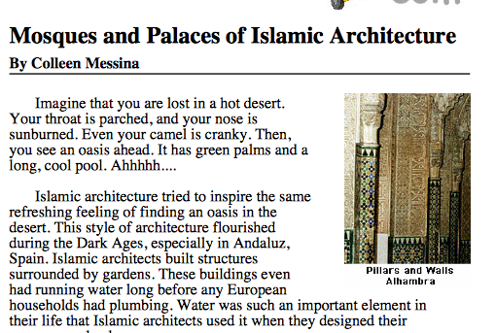 | Bell Work  What Islamic Invention do you think has had the greatest effect on our society today? Explain your answer in a 5 sentence paragraph | Whole class review of chapter 5 | Review of previous class writing assignment:  Individual Assignment  Chapter 5 Test  Examine your notes on Enlightenment that we discussed today and answer the questions in a 5-8 sentence paragraph.  How did the religion of Islam change over time | No School for Students  District Learning Day for Teachers
Guiding Questions | How do Ideas change the way people life? | - How do religions develop?  - How do Ideas change the way people life? | - How do religions develop?  - How do Ideas change the way people life? | - How do religions develop?  - How do Ideas change the way people life? | No School for Students  District Learning Day for Teachers

Instructional Strategies  I do… | PowerPoint Islamic Contributions  Notes  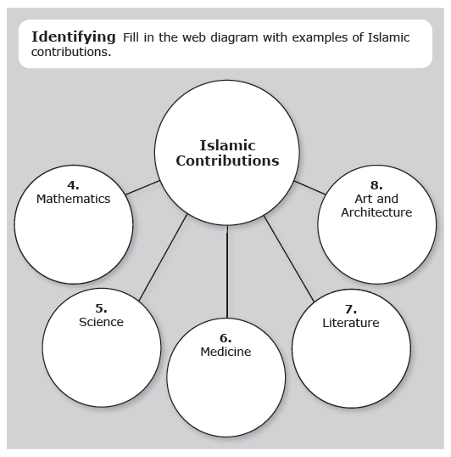 | Whole Class Review  Review the Guiding Questions, p. 121 | Individual Assignment  Chapter 5 Test  Examine your notes on Enlightenment that we discussed today and answer the questions in a 5-8 sentence paragraph.  How did the religion of Islam change over time? | Whole class instruction: Document Based Questions (introduction, directions) | No School for Students  District Learning Day for Teachers
Differentiated Tasks  We do … |  | Pick 3/5 to answer in chart formation.  - How did Islam change life on the Arabian Peninsula?  - How did it change life on the countries that became part of Islamic empires?  - How did Islam become a source of unity?  - How did Islam change over time?  - What parts of Islam did not change?  Changes Brought by Islam Unifying Aspects of Islam | Individual Assignment  Chapter 5 Test  Examine your notes on Enlightenment that we discussed today and answer the questions in a 5-8 sentence paragraph.  How did the religion of Islam change over time | Whole class instruction: Document Based Questions | No School for Students  District Learning Day for Teachers
Assessment  They do …. | Examine your notes on Enlightenment that we discussed today and answer the questions in a 5-8 sentence paragraph.  Why does Muslim art not depict living creatures? | Examine your notes on Enlightenment that we discussed today and answer the questions in a 5-8 sentence paragraph.  How did Muslims change other cultures and places as the religion of Islam spread? | Individual Assignment  Chapter 5 Test  Examine your notes on Enlightenment that we discussed today and answer the questions in a 5-8 sentence paragraph.  How did the religion of Islam change over time | Whole class instruction: Document Based Questions  (Discussion & Analysis) | No School for Students  District Learning Day for Teachers
Closure | Exit Slip  3: List 3 things you learned today  2: Explain 2 ways you contributed to class today  1: identify at least one question you still have. | Exit Slip  3: List 3 things you learned today  2: Explain 2 ways you contributed to class today  1: identify at least one question you still have. | Exit Slip  3: List 3 things you learned today  2: Explain 2 ways you contributed to class today  1: identify at least one question you still have. | Exit Slip  3: List 3 things you learned today  2: Explain 2 ways you contributed to class today  1: identify at least one question you still have. | No School for Students  District Learning Day for Teachers
Resources/Materials | Computer  Projector  Student text books  Interactive journals  Colored pencils  Tape/glue  TE-online book | Computer  Projector  Student text books  Interactive journals  Colored pencils  Tape/glue  TE-online book | Computer  Projector  Student text books  Interactive journals  Colored pencils  Tape/glue  TE-online book | Computer  Projector  Student text books  Interactive journals  Colored pencils  Tape/glue  TE-online book | No School for Students  District Learning Day for Teachers
Projected Assessments | *******UPDATED  Chapter 5: The Islamic World  - Chapter Assessment: Wednesday, September 16 (allowed to create and use “cheat chard”) | *******UPDATED  Chapter 5: The Islamic World  Chapter Assessment: Wednesday, September 16 (allowed to create and use “cheat chard”) | *******UPDATED  Chapter 5: The Islamic World  Chapter Assessment: Wednesday, September 16 (allowed to create and use “cheat chard”) |  | No School for Students  District Learning Day for Teachers
Additional notes/ Upcoming Events | Please make sure you are reviewing your notes from your interactive notebook each night.  Make sure to sign up for REMIND with Mrs. Stafford  ***** Parent Teacher Conference Night is Thursday. If you would like to schedule a conference please contact me by Wednesday, September 16 a5 8:30 am  staffordr@scsk12.org | Please make sure you are reviewing your notes from your interactive notebook each night.  Make sure to sign up for REMIND with Mrs. Stafford  ***** Parent Teacher Conference Night is Thursday. If you would like to schedule a conference please contact me by Wednesday, September 16 a5 8:30 am  staffordr@scsk12.org | Please make sure you are reviewing your notes from your interactive notebook each night.  Make sure to sign up for REMIND with Mrs. Stafford  ***** Parent Teacher Conference Night is Thursday. | Please make sure you are reviewing your notes from your interactive notebook each night.  Make sure to sign up for REMIND with Mrs. Stafford  ***** Parent Teacher Conference Night is Thursday. | No School for Students  District Learning Day for Teachers

