Teacher | Rachel Stafford
Class | 7th World History

 | Date:  Mon., January 4, 2016 | Date:  Tues., Jan. 5 | Date:  Wed. Jan. 6 | Date:  Thurs, Jan. 7 | Date:  Fri., Jan. 8
Standard | Teacher In-Service  No School for Students. | TN Core Standards  - 7.33 Describe the development of feudalism and manorialism, its role in the medieval European economy, and the way in which it was influenced by physical geography (the role of the manor and the growth of towns). (C, E, G, H, P)  - 7.34 Demonstrate understanding of the conflict and cooperation between the Papacy and European monarchs, including Charlemagne, Gregory VII, and Emperor Henry IV. (H, P)  7.51: Explain the institution and impact of missionaries on Christianity and the diffusion of Christians from Europe to other parts of the world | TN Core Standards  7.35: Examine the Norman Invasion, Battle of Hastings, and the impact of the reign of William the Conqueror on England and Northern France. | Geography  Bee | ½ day Students  Beginning of Winter Break
Objective  I can….. | Teacher In-Service  No School for Students. | Chapter 10  Medieval Europe  500-1475  I can analyze the geographic, political, economic, social and religious structures of the civilizations. | Chapter 10  Medieval Europe  500-1475  I can analyze the geographic, political, economic, social and religious structures of the civilizations. | Chapter 10  Medieval Europe  500-1475  I can analyze the geographic, political, economic, social and religious structures of the civilizations. | Chapter 10  Medieval Europe  500-1475  I can analyze the geographic, political, economic, social and religious structures of the civilizations.
Connections to Prior Knowledge | Teacher In-Service  No School for Students. | Bell Work  Discuss 10-1 & 10-2 HW Questions | Bell Work  What would life be life if no central government and no laws existed? | Bell Work  How did common law (Magna Carta) help unites England? | Discuss HW 10-3
Guiding Questions | Teacher In-Service  No School for Students. | - Why does conflict develop?  - What are the characteristics that define a culture?  - How do governments change?  - What is the role of religion in government? | - How was the king’s power strengthened and then limited in medieval England?  - How did the kings of France increase their power?  - How did the cities of Kiev and Moscow become centers of powerful Slavic states? | - Why did Western Europeans go on crusades? | - How was the king’s power strengthened and then limited in medieval England?  - How did the kings of France increase their power?  - How did the cities of Kiev and Moscow become centers of powerful Slavic states?  - Why did Western Europeans go on crusades?

Instructional Strategies  I do… | Teacher In-Service  No School for Students. | Text Dependent Questions  10-1 & 10-2 | Notes  - Royal Power in England  William the Conqueror  Henry II  The Magna Carta and Parliament  - Monarchy in France  - Eastern States of the Slavs  The Rise of Kiev  Mongol Invaders  The importance of Moscow  Ivan III Becomes Czar | Notes  - European Crusades  - the Crusades Begin  - Continued Conflict  - The Effects of the Crusades. | Review 10-3
Differentiated Tasks  We do … | Teacher In-Service  No School for Students. | Text Dependent Questions  10-1 & 10-2 | Text Dependent Monarchy in France (p. 263)  - What change in Government did the Estates-General Represent?  - How was the Estates-General of France different from England’s Parliament?  - In which of the three estates would you, as a student be categorized? Why?  Visual Analysis (p. 262)  - How can you tell where a kingdom stops and another begins?  - Which European kingdom is the most northern on this map?  - Why does the kingdom of England extend outside the British Isles?  - What empire is the largest? | Text Analysis Activity  -Analyze the Crusades | Quiz 10-3
Assessment  They do …. | Teacher In-Service  No School for Students. | Text Dependent Questions  10-1 & 10-2 | Vocabulary Box  Magna Carta  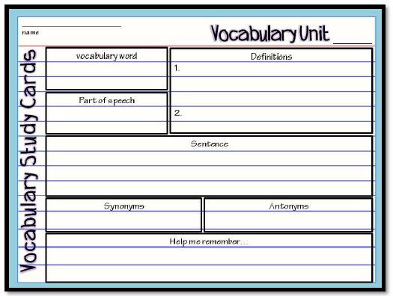 | Vocabulary Box  Crusades | Quiz 10-3  Finish Text Analysis Activity
Homework | Teacher In-Service  No School for Students. | Review Notes  10-3 HW is due Friday  10-3 Quiz is Friday | Review Notes  10-3 HW is due Friday  10-3 Quiz is Friday | Review Notes  10-3 HW is due Friday  10-3 Quiz is Friday | Review Notes
Closure | Teacher In-Service  No School for Students. | Exit Slip  3: List 3 things you learned today  2: Explain 2 ways you contributed to class today  1: identify at least one question you still have. | Exit Slip  3: List 3 things you learned today  2: Explain 2 ways you contributed to class today  1: identify at least one question you still have. | Exit Slip  3: List 3 things you learned today  2: Explain 2 ways you contributed to class today  1: identify at least one question you still have. | Exit Slip  3: List 3 things you learned today  2: Explain 2 ways you contributed to class today  1: identify at least one question you still have.
Resources/Materials | Teacher In-Service  No School for Students. | Computer  Projector  Student text books  Interactive journals  Colored pencils  Tape/glue  TE-online book | Computer  Projector  Student text books  Interactive journals  Colored pencils  Tape/glue  TE-online book | Computer  Projector  Student text books  Interactive journals  Colored pencils  Tape/glue  TE-online book | Computer  Projector  Student text books  Interactive journals  Colored pencils  Tape/glue  TE-online book
Projected Assessments | Teacher In-Service  No School for Students. | Chapter 10 Assessments  - 10-3 Quiz is Friday (open Journal) | Chapter 10 Assessments  - 10-3 Quiz is Friday (open Journal) | Chapter 10 Assessments  Chapter 10 Assessments  - 10-3 Quiz is Friday (open Journal)
Additional notes/ Upcoming Events | Teacher In-Service  No School for Students. | Please make sure you are reviewing your notes from your interactive notebook each night. | Please make sure you are reviewing your notes from your interactive notebook each night. | Please make sure you are reviewing your notes from your interactive notebook each night. | Please make sure you are reviewing your notes from your interactive notebook each night.

